**Consolidation: Using the mid-ordinate, trapezoidal and Simpson’s rule to calculate cut and fill for a road**

# Painted arrows and dashed line on a two-way single carriageway roadExercise 1

**Figure 2: A two-way single carriageway**Image © Shutterstock/Guillermo del Olmo

You are tasked with designing a section of new road that must pass through uneven terrain. To create a level road, you will need to cut soil from higher areas and fill soil to lower areas.

You have been provided with a contour plan of the site (see Figure 1) showing the position of the centre line of the new road.

The new road is proposed to be a two-way single carriageway (see Figure 2) with vehicles travelling in opposite directions in each lane. The lane width is a standard width of 3.65 metres. The ground level on which the road will be constructed is to be 72 metres.

Your task is to calculate the area of cut and fill using three different numerical methods: the mid-ordinate rule, the trapezoidal rule and Simpson’s rule.

**Figure 1:** Contour plan of the site showing the proposed route of the highway

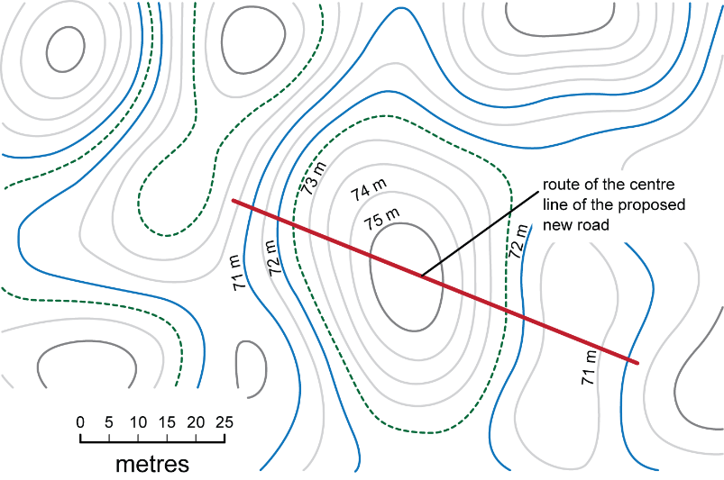

Use the contour plan to create a table of the ground elevation.

1. Use your ruler to measure and scale the length of the proposed new road.
2. Along the length of the road, record the distance of each contour from the start of the road. These are the x-values.
3. At each contour, record the ground level height. These are the y-values.

Use this table to record your answers. The first row has been completed for you. Round answers to 2.5 m.

|  |  |
| --- | --- |
| **Distance along the road (m)** | **Height (m)** |
| 0.0 | 70.5 |
|  |  |
|  |  |
|  |  |
|  |  |
|  |  |
|  |  |
|  |  |
|  |  |
|  |  |
|  |  |
|  |  |
|  |  |
|  |  |
|  |  |
|  |  |
|  |  |
|  |  |

Check your answers with the table provided on Consolidation Answer sheet 1.

# Exercise 2

Using the table from Consolidation Answer sheet 1, draw a graph of the existing ground level.

The x-axis should represent the distance along the road. The y-axis should represent the elevation.

Draw the proposed finished level of the road on the graph.

# Exercise 3

Using your graph:

1. Divide each area up into intervals.
2. Use the mid-ordinate, trapezoidal and Simpson’s rule to calculate the area of both cut and fill.

Remember: to apply Simpson’s rule, you must have an odd number of ordinates; Simpson’s rule will not work with an even number of ordinates.

1. Calculate the volume of cut and fill required across the width of the road.

Before continuing to the next step, check that you have calculated the areas of cut and fill using the Exercise 3 answers on Consolidation Answer sheet 2.

# Exercise 4

Compare the results you have obtained from the three methods, explaining any differences in the calculated areas and why those differences might have occurred.

Check your findings with the Consolidation Answer sheet 2.