Consolidation: answers 2

Exercise 2
Graphical plot of the existing ground levels along the centreline of the road:
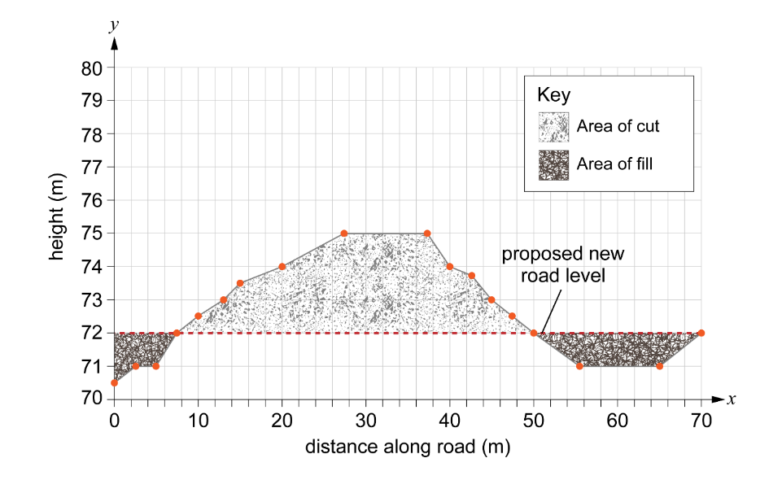

Exercise 3
We need to calculate the area using each of the different rules.
Remember: to be able to use Simpson’s rule, we need to have an odd number of ordinates, which means an even number of intervals. Therefore, it makes sense to select intervals for all three rules to achieve this.
The length of the road is 70 metres.
Use 14 intervals to give 15 ordinates for Simpson’s rule.
interval width = 70 ÷ 14 = 5 m

Mid-ordinate rule
Find the midpoint heights of each segment (or interval).
x-value (m) | Interval | Mid-ordinate (m)
2.5 | 1 | –1
7.5 | 2 | 0
12.5 | 3 | 1
17.5 | 4 | 1.75
22.5 | 5 | 2.33
27.5 | 6 | 3
32.5 | 7 | 3
37.5 | 8 | 3
42.5 | 9 | 1.5
47.5 | 10 | 0.5
52.5 | 11 | –0.5
57.5 | 12 | –1
62.5 | 13 | –1
67.5 | 14 | –0.5
Calculate the area of each segment.
Interval | Area = mid-ordinate × interval width (5 m)
1 | –1 × 5 = –5
2 | 0 × 5 = 0
3 | 1 × 5 = 5
4 | 1.75 × 5 = 8.75
5 | 2.33 × 5 = 11.65
6 | 3 × 5 = 15
7 | 3 × 5 = 15
8 | 3 × 5 = 15
9 | 1.5 × 5 = 7.5
10 | 0.5 × 5 = 2.5
11 | –0.5 × 5 = –2.5
12 | –1 × 5 = –5
13 | –1 × 5 = –5
14 | –0.5 × 5 = –2.5
Find the sum of all the interval areas to estimate the area of the cross-section:
$$A ≈-5+0+5+8.75+11.65+15+15+15+7.5+2.5-2.5-5-5-2.5=60.40 m^{2}$$

Trapezoidal rule
Find the ordinates at the end-points of each interval.
x-value (m) | y-ordinate number | Height (m)
0 | 1 | –1.5
5 | 2 | –0.5
10 | 3 | 0.5
15 | 4 | 1.5
20 | 5 | 2
25 | 6 | 2.67
30 | 7 | 3
35 | 8 | 3
40 | 9 | 2
45 | 10 | 1
50 | 11 | 0
55 | 12 | –1
60 | 13 | –1
65 | 14 | –1
70 | 15 | 0
$$Area ≈ \frac{1}{2} interval width×\left[first ordinate+2\left(sum of middle ordinates\right)+last ordinate\right]$$
interval width = 5
first ordinate = –1.5
sum of middle ordinates = –0.5 + 0.5 + 1.5 + 2 + 2.67 + 3 + 3 + 2 + 1 + 0 – 1 – 1 – 1 = 12.17
$$Area ≈ \frac{5}{2} ×\left[-1.5+2\left(12.22\right)+0\right]$$
$$Area ≈ 2.5 ×\left[-1.5+2\left(12.22\right)\right]$$
$$Area ≈ 2.5 ×\left[-1.5+24.34\right]$$
$Area ≈ 2.5 ×22.94=57.1$ m²

Simpson’s rule
Find the ordinates at the end-points of each interval.
x-value (m) | y-ordinate number | Height (m)
0 | 1 | –1.5
5 | 2 | –0.5
10 | 3 | 0.5
15 | 4 | 1.5
20 | 5 | 2
25 | 6 | 2.67
30 | 7 | 3
35 | 8 | 3
40 | 9 | 2
45 | 10 | 1
50 | 11 | 0
55 | 12 | –1
60 | 13 | –1
65 | 14 | –1
70 | 15 | 0

$A≈ \frac{1}{3} interval width × \left[first ordinate+4\left(sum of middle even ordinates\right) + 2\left(sum of middle odd ordinates\right)+ last ordinate\right]$
interval width = 5
first ordinate = –1.5
sum of middle even ordinates = -0.5 + 1.5 + 2.67 + 3 + 1 – 1 – 1 = 5.67
sum of middle odd ordinates = 0.5 + 2 + 3 + 2 + 0 – 1 = 6.5
$$A ≈ \frac{5}{3}\left(-1.5+4\left(5.67\right)+2\left(6.5\right)+0\right)$$
$$A ≈ \frac{5}{3}\left(-1.5+22.68 +13 \right)$$
$A ≈ \frac{5}{3}×34.18=56.97$ m²

Summary of results
To find the volume of fill to be exported from the site or reused, we multiply the total by the width of the road.
Lane width = 3.65 m
The road is a two-way single carriageway, so multiply the lane width by 2.
width of the road = 3.65 × 2 = 7.3 m
Rule | Total area | Volume of fill (area × road width)
Mid-ordinate | 60.40 m² | 60.40 × 7.3 = 440.92 m³
Trapezoidal | 57.1 m² | 57.1 × 7.3 = 416.83 m³
Simpson’s | 56.97 m² | 56.97 × 7.3 = 415.881 m³

Exercise 4
Comparing the results:
Some of the differences between the figures will be attributed to the fact that we have prepared a hand-drawn graph and used this to measure the ordinates. The accuracy largely depends on the smoothness of the graph and the precision with which the areas are drawn and divided. Human error in plotting points, drawing lines and reading ordinate values can lead to slight inaccuracies. Additionally, hand-drawn methods assume uniformity between intervals, which may not fully account for variations in the curve, making them more suitable for rough estimates rather than precise calculations.

