Activity 2: Worksheet answers

Practice question 1
Step 1: Plot the curve under the arch on graph paper.
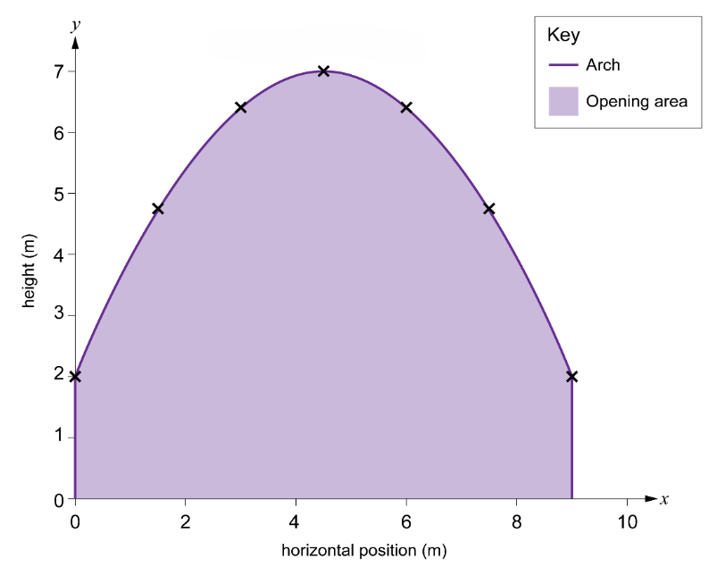
Step 2: Divide the base width of the cross-section into equal intervals.
The base width is 9 m.
6 intervals will give 7 ordinates.
interval width = 9 ÷ 6 = 1.5 m

Step 3: Label the points where you will measure the ordinates.
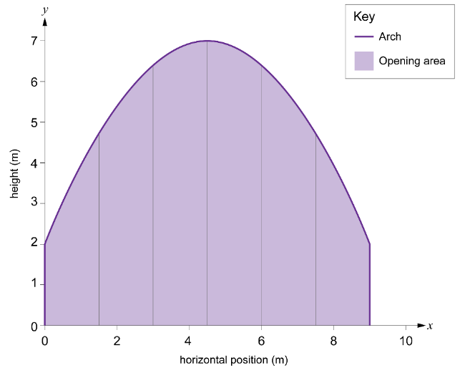
Step 4: Find the height of each ordinate.
The height of each ordinate is:
$y_{1}=2$ $y_{2}=4.78 m$
$y_{3}=6.44 m$ $y_{4}=7 m$
$y_{5}=6.44 m$ $y_{6}=4.78 my_{7}=2 m$
Step 5: Use Simpson’s rule to calculate the area under the curve.
$Area≈ \frac{1}{3} interval width × \left[first ordinate+4\left(sum of middle even ordinates\right) +2\left(sum of middle odd ordinates\right)+ last ordinate \right]$
interval width = 1.5
first ordinate = 2
sum of middle even ordinates = 4.78 + 7 + 4.78 = 16.56
sum of middle odd ordinates = 6.44 + 6.44 = 12.88
last ordinate = 2
$$Area ≈ \frac{1.5}{3}\left(2+4\left(16.56\right)+2\left(12.88\right)+2\right)$$
$$Area ≈0.5 \left(2+ 66.24+25.76+2\right)Area ≈ 0.5×96$$
$Area ≈ 48$ m²

Practice question 2
Step 1: Plot the curve under the arch on graph paper.
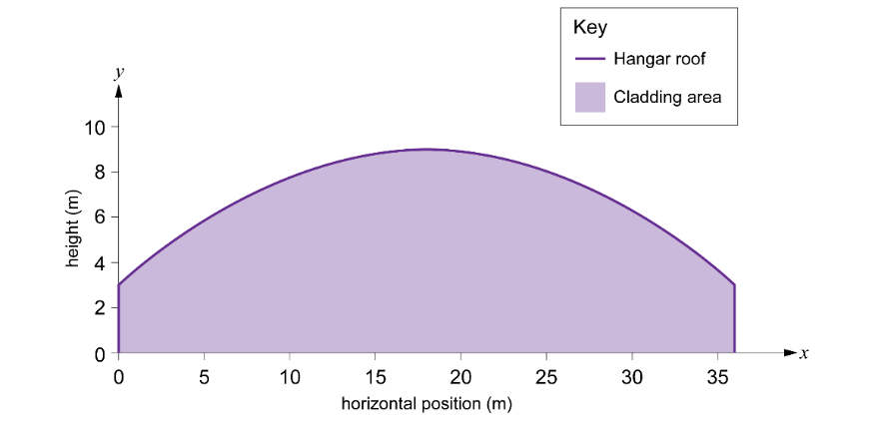
Step 2: Divide the base width of the cross-section into equal intervals.
The base width is 36 m.
12 intervals gives 13 ordinates.
interval width = 36 ÷ 12 = 3 m
Step 3: Label the points where you will measure the ordinates.
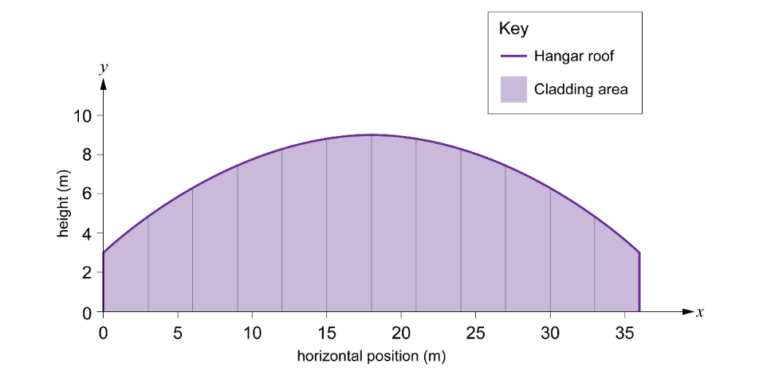
Step 4: Find the height of each ordinate.
The height of each ordinate is:
$y_{1}=3 m$ $y_{2}=4.83 m$

$y_{3}=6.33 m$ $y_{4}=7.5 m$
$y_{5}=8.33 m$ $y_{6}=8.83 m$
$y_{7}=9 m$ $y_{8}=8.83 m$
$y_{9}=8.33 m$ $y_{10}=7.5 m$
$y_{11}=6.33 m$ $y_{12}=4.83 m$
$y_{13}=3 m$
Step 5: Use Simpson’s rule to calculate the area under the curve.
$A≈ \frac{1}{3} interval width × \left[first ordinate+4\left(sum of middle even ordinates\right) +2\left(sum of middle odd ordinates\right)+ last ordinate\right]$
interval width = 3
first ordinate = 3
sum of middle even ordinates = 4.83 + 7.5 + 8.83 + 8.83 + 7.5 + 4.83 = 42.32
sum of middle odd ordinates = 6.33 + 8.33 + 9 + 8.33 + 6.33 = 38.32
last ordinate = 3
$$A ≈ \frac{3}{3}\left(3+4\left(42.32\right)+2\left(38.32\right)+3\right)$$
$$A ≈ 3+4\left(42.32\right)+2\left(38.32\right)+3$$
$A ≈3+169.28+76.64+3$ = 251.92

