**Activity 2 Worksheet: Using Simpson’s rule to calculate the area under a curve**

# A large, arched opening made of white brick in a wall.Practice question 1

As part of some renovation work, a contractor needs to fill in an old arched opening to create an internal room. You have been asked to use Simpson’s rule to calculate the overall area so that eventually the number of stone blocks needed can be calculated.

The arch has a width of 9 metres, and the heights are given in the table below.

**Image © Shutterstock/Olena Kozachuk**

**Image © Shutterstock/Olena Kozachuk**

|  |  |
| --- | --- |
| **Position (m)** | **Arch height (m)** |
| 0 | 2 |
| 1.5 | 4.78 |
| 3.0 | 6.44 |
| 4.5 | 7 |
| 6.0 | 6.44 |
| 7.5 | 4.78 |
| 9.0 | 2 |

Remember to work through each step in turn.

**Step 1**: Plot the curve under the arch on graph paper.

**Step 2**: Divide the base width of the cross-section into equal intervals.

**Step 3**: Label the points where you will measure the ordinates.

**Step 4**: Find the height of each ordinate.

**Step 5**: Use Simpson’s rule to calculate the area under the curve.

$A≈ \frac{1}{3} interval width × \left[first ordinate+4\left(sum of middle even ordinates\right) +2\left(sum of middle odd ordinates\right)+ last ordinateu\right]$

# Practice question 2

You are tasked with cladding the back elevation of a metal hangar, like the one below. The back elevation of the hangar has a curved shape, and its dimensions are provided in the table below. The total width of the hangar’s base is 36 m.

Use Simpson’s rule to calculate how much cladding material is needed.

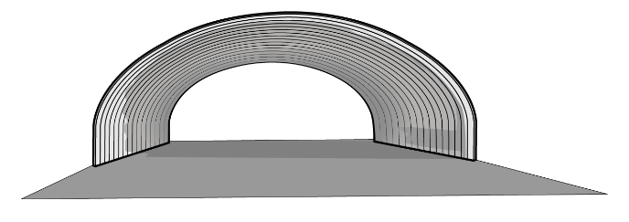

|  |  |
| --- | --- |
| **Position (m)** | **Hangar height (m)** |
| 0 | 3 |
| 3 | 4.83 |
| 6 | 6.33 |
| 9 | 7.5 |
| 12 | 8.33 |
| 15 | 8.83 |
| 18 | 9 |
| 21 | 8.83 |
| 24 | 8.33 |
| 27 | 7.5 |
| 30 | 6.33 |
| 33 | 4.83 |
| 36 | 3 |