Using Simpson’s rule to calculate the area under a curve

Worked example
You are constructing a curved roof and wish to calculate the area of bricks that will be needed to complete the area under the roof.
The roof line of the building can be represented by a quadratic equation in the form:
$$y = -0.2x^{2} + 4x$$
Step 1: Plot the curve on graph paper.
This has been done for you.

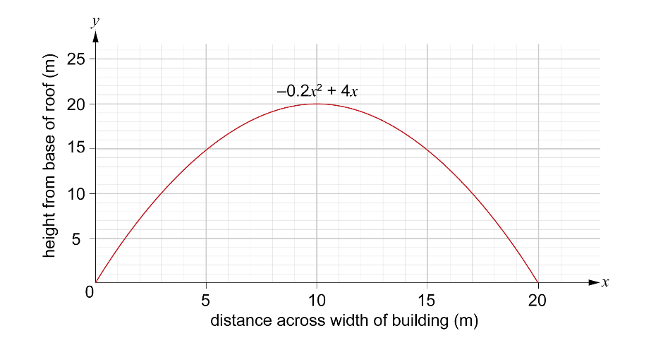

Step 2: Divide the base width of the cross-section into equal intervals.
Remember: Simpson’s rule requires an odd number of ordinates. This means you need an even number of intervals.
The base width is 20 metres.
10 intervals give 11 ordinates.
interval width = 20 ÷ 10 = 2 m
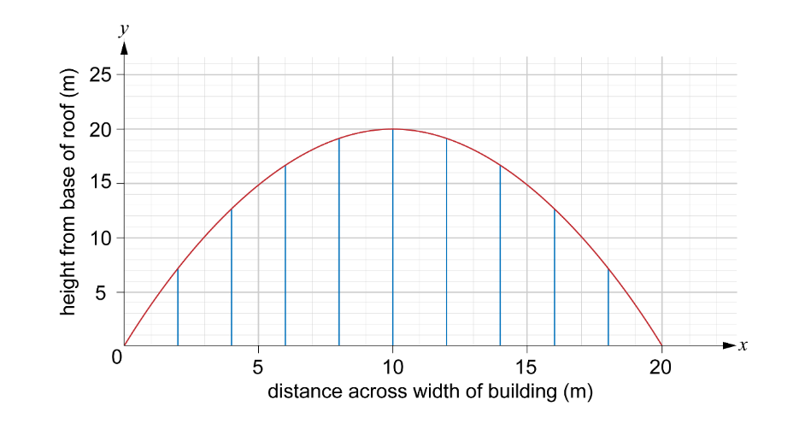
Step 3: Label the points where you will measure the ordinates.
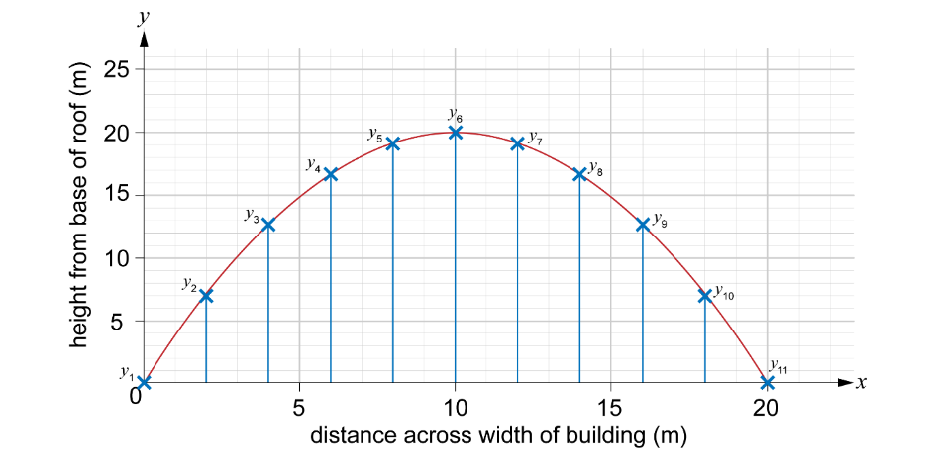
Step 4: Find the height of each ordinate.
$y_{1}=0 m$ $y_{2}=7 my_{3}=13 m$ $y_{4}=17 m$
$y_{5}=19 m$ $y_{6}=20 m$
$y_{7}=19 m$ $y_{8}=17 m$
$y_{9}=13 m$ $y_{10}=7 m$
$y_{11}=0 m$
Step 5: Calculate the area under the curve using Simpson’s rule.
$A≈ \frac{1}{3} interval width × \left[first ordinate+4\left(sum of middle even ordinates\right) + 2\left(sum of middle odd ordinates\right)+ last ordinate\right]$
interval width = 2
first ordinate = 0
sum of middle even ordinates = 7 + 17 + 20 + 17 + 7 = 68
sum of middle odd ordinates = 13 + 19 + 19 + 13 = 64
last ordinate = 0
$$A ≈ \frac{2}{3}\left(4\left(68\right)+2(64)\right)$$
$$A ≈ \frac{2}{3}\left(272+128\right)$$
$A ≈ \frac{2}{3}\left(272+128\right)=266.33$ m²
So, enough bricks will need to be purchased to cover an area of 267 m².

