Activity 1 Worksheet (scaffolded): Using the trapezoidal rule to calculate the materials for a road embankment

Practice question 1
You are constructing a road embankment with a cross-sectional base width of 10 metres as shown. The embankment will be 15 metres long. Calculate the amount of fill needed to construct the embankment.
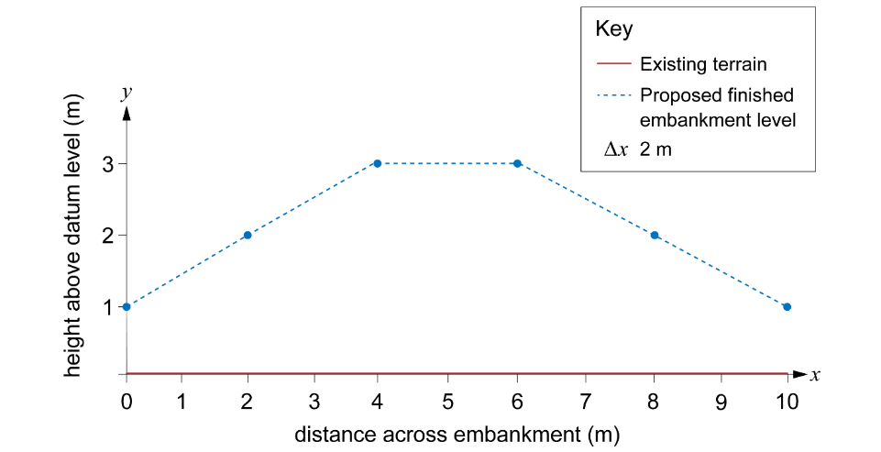
Step 1: Plot the x- and y-coordinates on graph paper.
This has been done for you.
Step 2: Divide the base width of the cross-section into equal intervals.
The base width is 10 metres.
If we divide it into five equal intervals, how large should each section be?
Interval width = ____________
Add the intervals to the graph.
Step 3: Label the points where you will measure the ordinates.
Remember, this is at the start and end of each interval.
Add labels to your graph $y_{1}$–$y_{6}$ showing where you will measure them.
Step 4: Find the heights of each ordinate.
$y_{1}$ = ________ m
$y_{2}$ = ________ m
$y_{3}$ = ________ m
$y_{4}$ = ________ m
$y_{5}$ = ________ m
$y_{6}$ = ________ m
Step 5: Calculate the area of fill required using the trapezoidal rule.
$$Area ≈ \frac{1}{2} interval width ×\left[first ordinate+2\left(sum of middle ordinates\right)+last ordinate\right]$$
first ordinate = ________
sum of middle ordinates = ________ + ________ + ________ + ________ = ________
last ordinate = ________

= $\frac{1}{2}$× ________ [________ + 2 (________) + ________]

= ________ [________ + ________ + ________]

= ________ m²

Step 6: Work out the total amount of material needed by multiplying the area of the cross-section by the length of the embankment.
Total volume of fill material required = ______________ m³

Practice question 2
Use the trapezoidal rule to calculate the area of another road embankment with a base width of 12 metres divided into six equal segments.
The heights are as given in the table.
You can assume that the existing ground level is at 0 metres.
Position (m) | Proposed height (m)
0 | 2.5
2 | 3
4 | 5
6 | 5
8 | 5
10 | 3
12 | 2.5
Remember to work through each step in turn:
Step 1: Sketch the embankment onto graph paper using the values in Table 2.
Step 2: Divide the base width into equal intervals.
Step 3: Label the points where you will measure the ordinates.
Step 4: Find the heights of each ordinate.
Step 5: Calculate the area of fill required using the trapezoidal rule.

Practice question 3
You are designing a road that must pass through uneven terrain. To create a level road, you will need to cut soil from higher areas and fill soil to lower areas. The longitudinal section of the terrain along a 16-metre stretch of road is given in the table.
Use the trapezoidal rule to calculate how much material will need to be removed from site to create a suitable road. The road will be 9 metres wide.
Position (m) | Existing elevation (m) | Desired elevation (m)
0 | 3.5 | 3
2 | 4 | 3
4 | 3.5 | 3
6 | 3.25 | 3
8 | 3 | 3
10 | 2 | 3
12 | 1.5 | 3
14 | 1 | 3
16 | 1 | 3
Remember to work through each step in turn.
Start by sketching the road on graph paper and draw in the proposed road level. You will need to measure the heights from this line to work out the areas of cut and fill.

