Activity 1: Worksheet answers

Practice question 1
Step 1: Plot the data.
This was done for you.
Step 2: Divide the base width into equal intervals.
The base width is 10 m. The number of intervals is 5.
Therefore, the interval width is 10 ÷ 5 = 2 m.
(See graph below.)
Step 3: Identify the ordinates on the graph
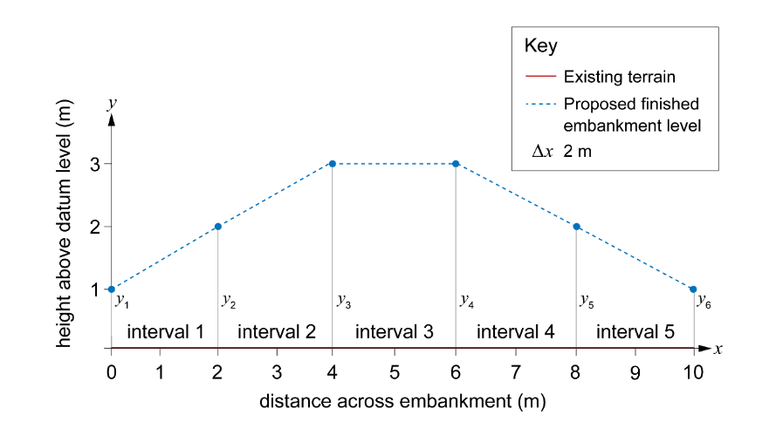
Step 4: Find the heights of the ordinates.
$$y_{1}=1 m$$
$$y_{2}=2 m$$
$$y_{3}=3 m$$
$$y_{4}=3 m$$
$$y_{5}=2 m$$
$y_{6}=1 m$
Step 5: Use the trapezoidal rule to calculate the area of cut and fill.
$Area ≈ \frac{1}{2} interval width ×\left[first ordinate+2(sum of middle ordinates)+last ordinate\right]$
interval width = 2
first ordinate = 1
sum of middle ordinates = 2 + 3 + 3 + 2 = 10
last ordinate = 1
$$Area ≈ \frac{2}{2} ×[1+2\left(10\right)+1]$$
$$Area ≈ 1 ×\left[1+2\left(10\right)+1\right]$$
$$Area≈ 1+20+1$$
$Area≈ 22$ m²
Step 6: Calculate the total volume of fill material required.
Total volume of fill material required = 22 × 15 = 330 m³

Practice question 2
Step 1: Plot the embankment onto graph paper using the values in the table.
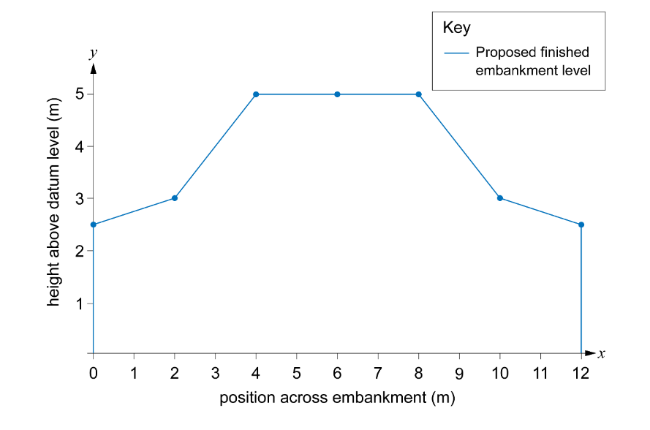
Step 2: Divide the base width into equal intervals.
The base width is 12 m. The number of intervals is 6.
Therefore, the interval width is = 12 ÷ 6 = 2 m
Step 3: Identify the ordinates on the graph.
These should be labelled as $y_{1}$ to $y_{7}$.
Step 4: Find the heights of the ordinates:
$$y_{1}=2.5 m$$
$$y_{2}=3 m$$
$$y_{3}=5 m$$
$$y_{4}=5 m$$
$$y_{5}=5 m$$
$$y_{6}=3 m$$
$$y_{7}=2.5 m$$
Step 5: Use the trapezoidal rule to calculate the area of cut and fill.
$Area ≈ \frac{1}{2} interval width ×\left[first ordinate+2(sum of middle ordinates)+last ordinate\right]$
first ordinate = 2.5
sum of middle ordinates = 3 + 5 + 5 + 5 + 3 = 21
last ordinate = 2.5
$$Area ≈ \frac{2}{2} ×[2.5+2\left(21\right)+2.5]$$
$$Area ≈ 1 ×[2.5+2\left(21\right)+2.5]$$
$Area ≈ 2.5+42+2.5=47$ m²
$Area ≈ 47$ m²

Practice question 3
Step 1: Plot the embankment onto graph paper using the values in the table.
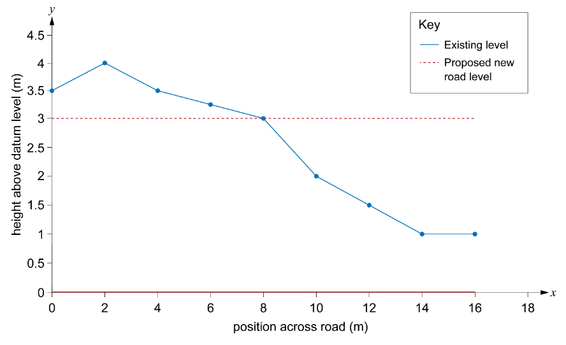Step 2: Divide the base width into equal intervals.
The base width is 10 m. The number of intervals is 8.
Therefore, the interval width is 16 ÷ 8 = 2 m.
Step 3: Identify the ordinates on the graph
These should be labelled as $y_{1}$ to $y_{9}$.
Step 4: Find the heights of the ordinates.
The areas of cut are positive values as they are above the proposed new level.
$$y_{1}=0.5 m$$
$$y_{2}=1 m$$
$$y_{3}=0.5 m$$
$$y_{4}=0.25 m$$
$$y_{5}=0 m$$

The areas of fill are negative values as they are below the proposed new level.
$$y_{6}=-1 m$$
$$y_{7}=-1.5 m$$
$$y_{8}=-2 m$$
$$y_{9}=-2 m$$
Step 5: Use the trapezoidal rule to calculate the area of cut and fill.
$Area ≈ \frac{1}{2} interval width ×\left[first ordinate+2(sum of middle ordinates)+last ordinate\right]$
first ordinate = 0.5
sum of middle ordinates = 1 + 0.5 + 0.25 + 0 – 1 – 1.5 – 2 = –2.75
last ordinate = –2
$$Area ≈ \frac{2}{2} ×\left[0.5+2\left(-2.75\right)-2\right]$$
$$Area ≈ 1 ×\left[0.5+2\left(-2.75\right)-2\right]$$
$$Area ≈ 0.5-5.5-2$$
$Area ≈ -7$ m²
The result is negative, which means that more material is needed than there is on the site. The earthworks contractor will need to bring 7.0 m² of earth per metre width of road (7.0 m³) to the site.
Step 6: Calculate the total amount of soil to be added.
7 × 9 = 63 m³

