Activity 1 Worksheet: Using the trapezoidal rule to calculate the materials for a road embankment

Practice question 1
You are constructing a road embankment with a cross-sectional base width of 10 metres as shown below. The embankment will be 15 metres long. Calculate the amount of fill needed to construct the embankment.
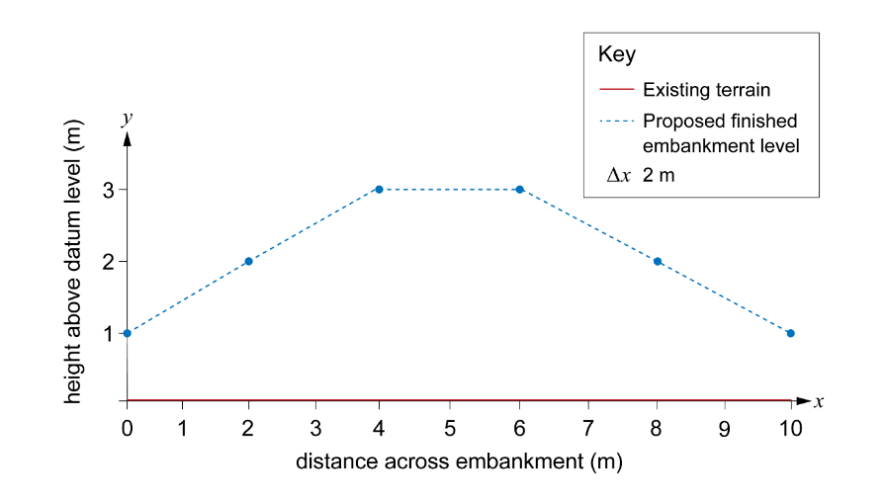
Remember to work through each step in turn.
Step 1: Plot the x- and y-coordinates on graph paper.
Step 2: Divide the base width of the cross-section into equal intervals.
Step 3: Label the points where you will measure the ordinates.
Step 4: Find the heights of each ordinate.
Step 5: Calculate the area of fill required using the trapezoidal rule.
$$Area ≈ \frac{1}{2} interval width ×\left[first ordinate+2\left(sum of middle ordinates\right)+last ordinate\right]$$
Step 6: Work out the total amount of material needed by multiplying the area of the cross-section by the length of the embankment.

Practice question 2
Using the trapezoidal rule, calculate the area of another road embankment with a base width of 12 metres divided into 6 equal intervals. The heights are as given in the table. You can assume that the existing ground level is at 0 metres.
Position (m) | Proposed height (m)
0 | 2.5
2 | 3
4 | 5
6 | 5
8 | 5
10 | 3
12 | 2.5
Hint: Remember to work through each step in turn, starting by sketching the embankment.

Practice question 3
You are designing a road that must pass through uneven terrain. To create a level road, you will need to cut soil from higher areas and fill soil to lower areas. The cross-section of the terrain along a 16-metre stretch of road is given in the table.
Use the trapezoidal rule to calculate how much material will need to be removed from site to create a suitable road. The road will be 9 metres wide.
Position (m) | Existing elevation (m) | Desired elevation (m)
0 | 3.5 | 3
2 | 4 | 3
4 | 3.5 | 3
6 | 3.25 | 3
8 | 3 | 3
10 | 2 | 3
12 | 1.5 | 3
14 | 1 | 3
16 | 1 | 3
Hint: Remember when sketching the road on graph paper to also add in the proposed road level. You will need this to work out the areas of cut and fill.

