Using the trapezoidal rule calculate the materials for an embankment

Worked example
You are tasked with designing a road that must pass through uneven terrain.
To create a level road, you will need to cut soil from higher areas and fill soil to lower areas.
The elevations of the cross-section of the terrain along a 10-metre stretch of road are given in the table. The proposed new ground level on which the road will be constructed is at an elevation of 2 metres.
Position (m) | Existing elevation (m) | Desired elevation (m)
0 | 2.5 | 2
2 | 3 | 2
4 | 2 | 2
6 | 1.5 | 2
8 | 1 | 2
10 | 1 | 2
Step 1: Plot the x- and y-coordinates on graph paper.
See the graph below.
Step 2: Divide the base width of the cross-section into equal intervals.
The base width is 10 m. The number of intervals is 5.
Therefore, the interval width is 10 ÷ 5 = 2 m.
Step 3: Label the points where you will measure the ordinates.
See the graph below.
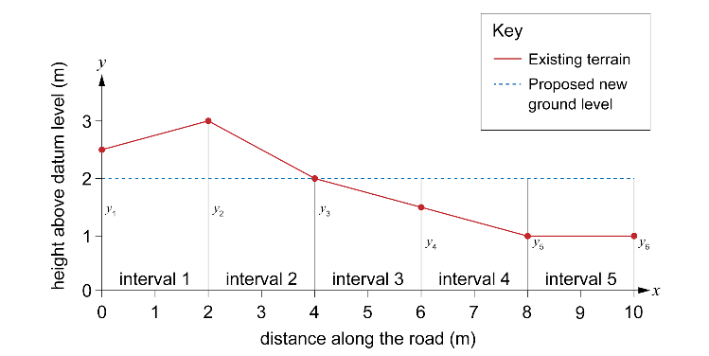
Step 4: Measure the height of the cut or fill at each point.
Each time, measure the height from the proposed finished level to the ordinate. The areas of cut are positive values as the heights are above the proposed new ground level.
$$y_{1}=0.5 m$$
$$y_{2}=1 m$$
$$y_{3}=0 m$$
The areas of fill are negative values as extra material is needed to fill in these sections.
$$y_{4}=-0.5 m$$
$$y_{5}=-1 m$$
$$y_{6}=-1 m$$
Step 5: Use the trapezoidal rule to calculate the area of cut and fill.
$Area ≈ \frac{1}{2} interval width ×\left[first ordinate+2(sum of middle ordinates)+last ordinate\right]$
interval width $=2$
first ordinate $=0.5$
sum of middle ordinates $=1+ 0-0.5-1= -0.5$
last ordinate $=-1$
$$Area ≈ \frac{2}{2} ×[0.50+2\left(-0.5\right)-1]$$
$$Area ≈ 1 ×[0.5+2\left(-0.5\right)-1]$$
$$Area ≈ 0.5-1-1$$
$Area ≈ -1.5$ m²

As the result is negative, the fill area is greater than the cut area. The earthworks contractor will need to bring 1.5 m² extra of earth per metre width of road.

