Consolidation
The mid-ordinate rule is used in construction to calculate cross-sectional areas of structures like road embankments, trenches and channels. Accurate measurements of these areas are important for planning how much material is needed and its associated costs.
These questions will help you practise using the mid-ordinate rule in different construction scenarios. Answers to these questions can be found in the Teaching Guide.

Practice exercise 1
You are tasked with designing a water channel. The cross-section of the channel is irregular, and the base is 15 metres wide. The profile of the channel has been divided into five equal segments. The depths at the given positions are shown in this table.
Use the mid-ordinate rule to calculate the approximate cross-sectional area of the channel. Assume that the existing ground level is at 0 metres.
Position (m) | Depth (m)
0 | 1.5
3 | 2.0
6 | 2.8
9 | 2.6
12 | 1.8
15 | 1.5

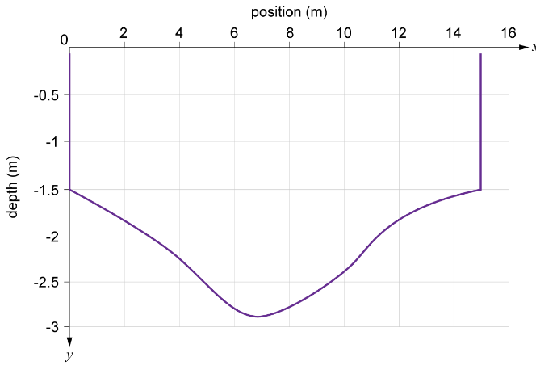

Practice exercise 2
You are designing an embankment for a railway track that spans 18 metres, which is divided into six equal intervals. The heights at each ordinate are given in the table below. Use the mid-ordinate rule to estimate the area of the embankment’s cross-section.
Position (m) | Height (m)
0 | 4.0
3 | 4.5
6 | 5.0
9 | 5.0
12 | 5.0
15 | 4.5
18 | 4.0
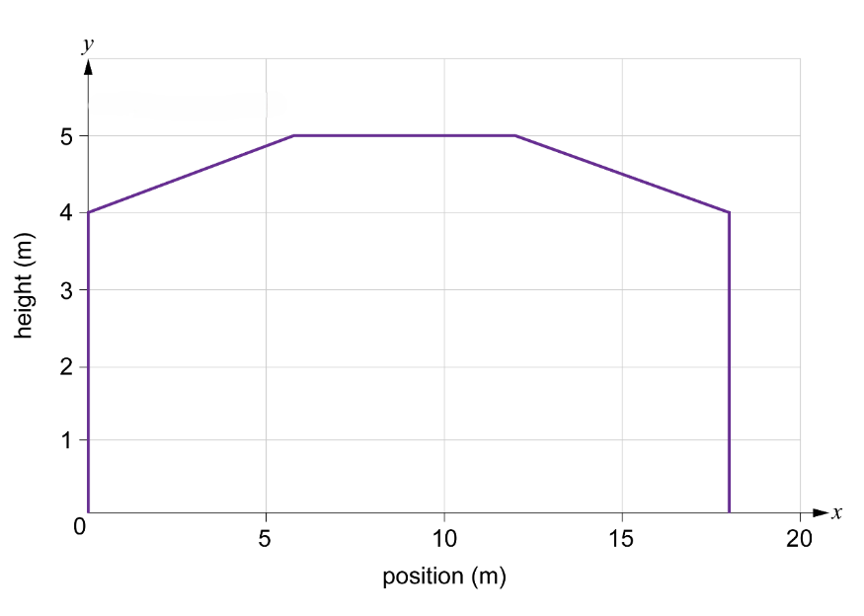

Practice exercise 3
An attenuation basin needs to be excavated. This will act as a buffer for surface waters that run off the land quickly after heavy rain.
The base width of the basin is 8 metres, and it is divided into four equal segments.
The depths at the given positions are given in the table. Use the mid-ordinate rule to calculate the cross-sectional area of the attenuation basin.
Assume the current ground level is 0 metres.
Position (m) | Depth (m)
0 | 1.2
2 | 1.6
4 | 2.0
6 | 1.4
8 | 1.2

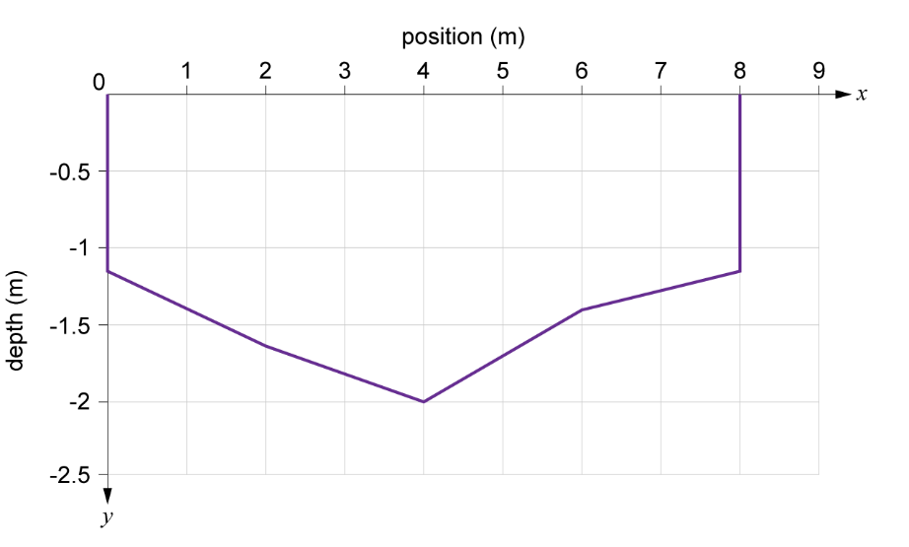

Practice exercise 4
You are constructing a road across a small hill with varying heights. The base of the road is 10 metres wide. The width has been split into five equal intervals and the heights of the terrain at each position are given in the table.
Use the mid-ordinate rule to estimate how much material will need to be removed to create a suitable ground level to construct the road at 0 metres.
Position (m) | Height (m)
0 | 3.0
2 | 3.5
4 | 4.0
6 | 3.5
8 | 3.0
10 | 3.75

