Activity 2 Worksheet (scaffolded): Using the mid-ordinate rule to calculate the materials for a road embankment

Practice question 1
You are constructing a road embankment with a cross-sectional base width of 10 metres, as shown. The embankment will be 15 metres long.
Calculate the amount of fill needed to construct the embankment.
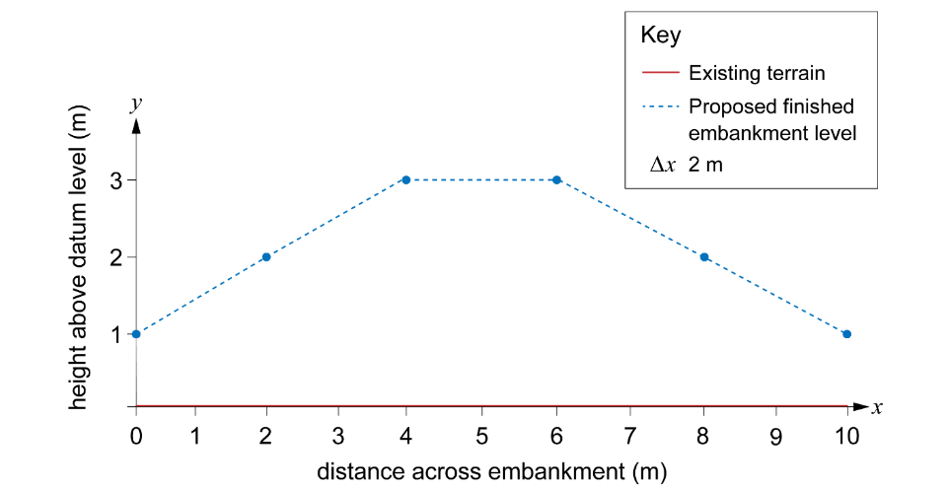
Step 1: Plot the ‘x’ and ‘y’ co-ordinates on graph paper.
This has been done for you for this question.
Step 2: Divide the base width of the cross-section into equal intervals.
The base width is 10 m.
If we divide it into five equal intervals, how large should each section be?
Interval width = ____________
Add the intervals to the graph.
Step 3: Determine the midpoint of each interval.
Remember, this should be at the halfway point in each interval.
Add crosses to your graph to show the midpoints.
Step 4: Measure the height of the fill at each point.
Interval 1 = ________ m
Interval 2 = ________ m
Interval 3 = ________ m
Interval 4 = ________ m
Interval 5 = ________ m
Step 5: Calculate the area of each interval.
Remember, this is the midpoint height × the interval width.
Interval 1 area = ________ m × ________ m = ________ m²
Interval 2 area = ________ m × ________ m = ________ m²
Interval 3 area = ________ m × ________ m = ________ m²
Interval 4 area = ________ m × ________ m = ________ m²
Interval 5 area = ________ m × ________ m = ________ m²
Step 6: Add up the areas of all the intervals to get the total area of the cross-section.
Note that as this is additional material for an embankment, no material needs to be removed.

Total area of cross-section = ________ m²
Step 7: Work out the total amount of material needed by multiplying the area of the cross-section by the length of the embankment.

Total volume of fill material required = ________ m³

Practice question 2
Use the mid-ordinate rule to calculate the cross-sectional area of another road embankment with a base width of 12 metres divided into six equal segments.
The heights are given in the table.
You can assume that the existing ground level is at 0 metres.
Position (m) | Proposed height (m)
0 | 2.5
2 | 3
4 | 5
6 | 5
8 | 5
10 | 3
12 | 2.5
Remember to work through each step in turn:
Step 1: Sketch the embankment onto graph paper using the values in Table 2.
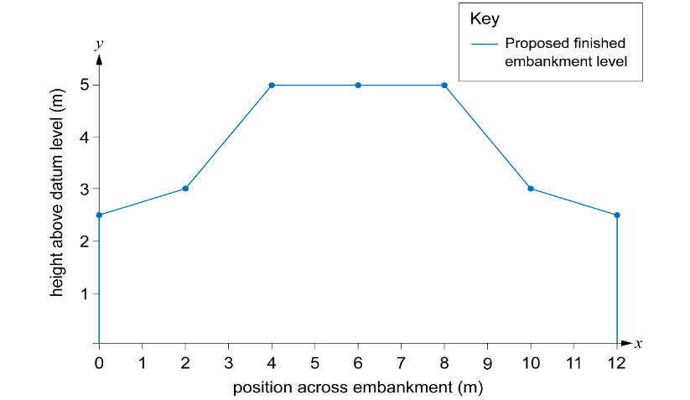
Step 2: Divide the base width into equal intervals.
Step 3: Find the midpoint of each interval.
Step 4: Find the midpoint heights of each interval.
Step 5: Calculate the area of each interval.
Step 6: Add up the areas of the segment to get the total area of the cross-section.

Practice question 3
You are designing a road that must pass through uneven terrain. To create a level road, you will need to cut soil from higher areas and fill soil to lower areas.
The cross-section of the terrain along a 10-metre stretch of road is given in the table and graph below.
Use the mid-ordinate rule to calculate how much material will need to be removed from site to create a suitable road. The road will be 9 m wide.
Position (m) | Existing elevation (m) | Desired elevation (m)
0 | 3.5 | 3
2 | 3 | 3
4 | 3.5 | 3
6 | 3.5 | 3
8 | 2.5 | 3
10 | 2 | 3
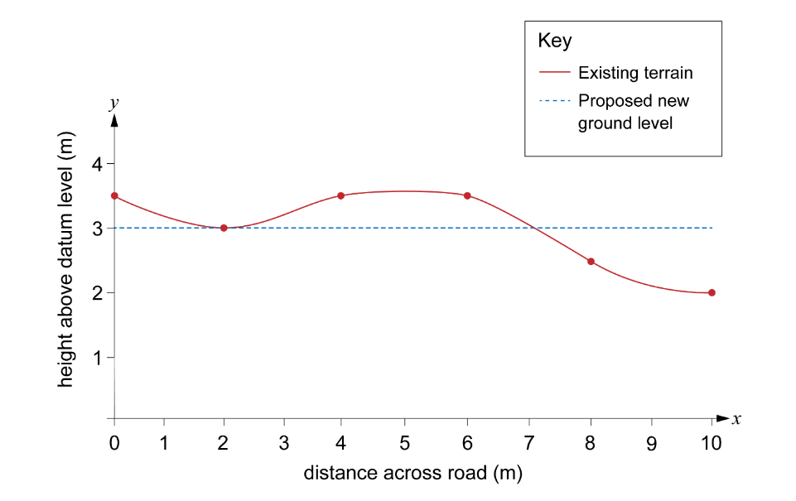
Remember to work through each step in turn and draw in the proposed road level. You will need to measure the heights from this line to work out the areas of cut and fill.

