Activity 2: Worksheet answers

Practice question 1
Step 1: Plot data as shown.
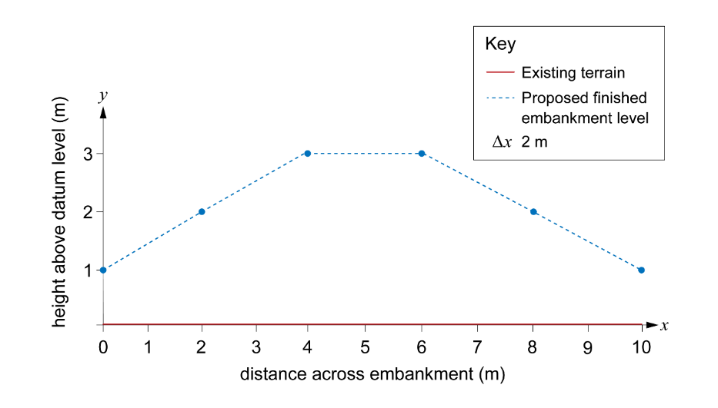
Step 2: Divide the base width into equal intervals
Interval width = 10 ÷ 5 = 2 m
Steps 3 and 4: Interval midpoint heights
Interval 1 = 1.5 m Interval 2 = 2.5 m
Interval 3 = 3 m Interval 4 = 2.5 m
Interval 5 = 1.5 m
Step 5: Interval areas
Interval 1 area = 1.5 m × 2 m = 3 m² Interval 2 area = 2.5 m x 2 m = 5 m²
Interval 3 area = 3 m × 2 m = 6 m² Interval 4 area = 2.5 m × 2 m = 5 m²
Interval 5 area = 1.5 m × 2 m = 3 m²
Step 6:
Area of fill = 3 + 5 + 6 + 5 + 3 = 22 m²
Step 7:
Total volume of fill material required = 22 × 15 = 330 m³

Practice question 2
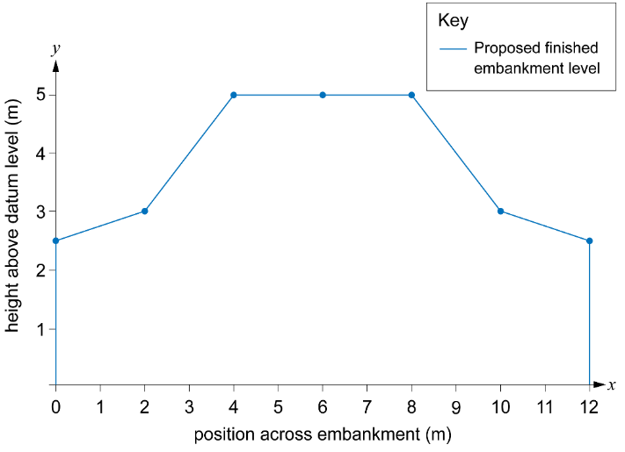
Step 1: Sketch the embankment onto graph paper using the values in the table.
Position (m) | Proposed height (m)
0 | 2.5
2 | 3
4 | 5
6 | 5
8 | 5
10 | 3
12 | 2.5

Step 2: Divide the base width into equal intervals.
The base width is 12 m. The number of intervals is 6.
Therefore, the interval width = 12 ÷ 6 = 2 m
Steps 3 and 4: Find the midpoint heights of each interval.
Interval 1 = 2.75 m Interval 2 = 4 m
Interval 3 = 5 m Interval 4 = 5 m
Interval 5 = 4 m Interval 6 = 2.75 m
Step 5: Calculate the area of each interval.
Interval 1 area = 2.75 m × 2 m = 5.5 m² Interval 2 area = 4 m × 2 m = 8 m²
Interval 3 area = 5 m × 2 m = 10 m² Interval 4 area = 5 m × 2 m = 10 m²
Interval 5 area = 4 m × 2 m = 8 m² Interval 6 area = 2.75 m × 2 m = 5.5 m²
Step 6: Add up the areas of the intervals to get the total area of the cross-section.
5.5 + 8 + 10 + 10 + 8+ 5.5 = 47 m²

Practice question 3
Step 1: Sketch the road onto graph paper using the values in the table.
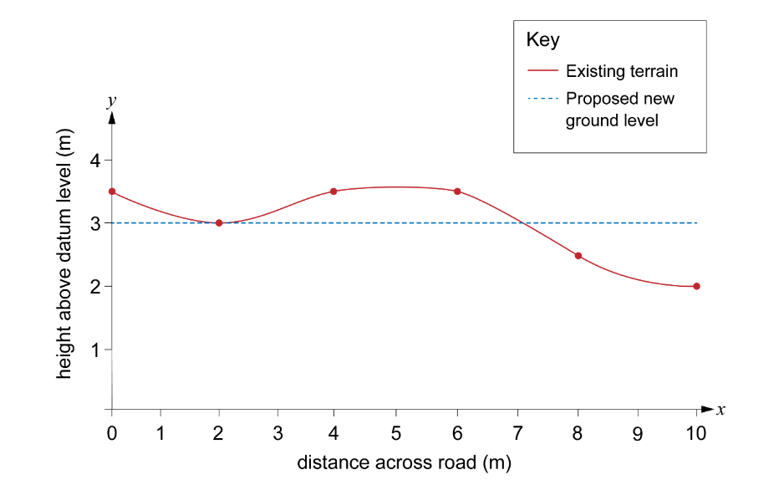Step 2: Divide the base width into equal intervals.
The base width is 10 m. The number of intervals is 5.
Therefore, the interval width is 10 ÷ 5 = 2 m.
Steps 3 and 4: Find the midpoint heights of each interval.
Interval 1 = 0.25 m Interval 2 = 0.25 m
Interval 3 = 0.5 m Interval 4 = 0 m
Interval 5 = –0.75 m
Step 5: Calculate the area of each interval.
Interval 1 area = 0.25 m × 2 m = 0.5 m² Interval 2 area = 0.25 m × 2 m = 0.5 m²
Interval 3 area = 0.5 m × 2 m = 1 m² Interval 4 area = 0 m × 2 m = 0 m²
Interval 5 area = –0.75 m × 2 m = –1.5 m²
Step 6: Add up the areas of the intervals to get the total area of the cross-section.
0.5 + 0.5 + 1 + 0 – 1.5 = 0.5 m²
Step 7: Calculate the volume of earth needing to be removed.
0.5 × 9 = 4.5 m³

