Activity 2 Worksheet: Using the mid-ordinate rule to calculate the materials for a road embankment

Practice question 1
You are constructing a road embankment with a cross-sectional base width of 10 metres as shown below. The embankment will be 15 metres long.
Calculate the amount of fill needed to construct the embankment.
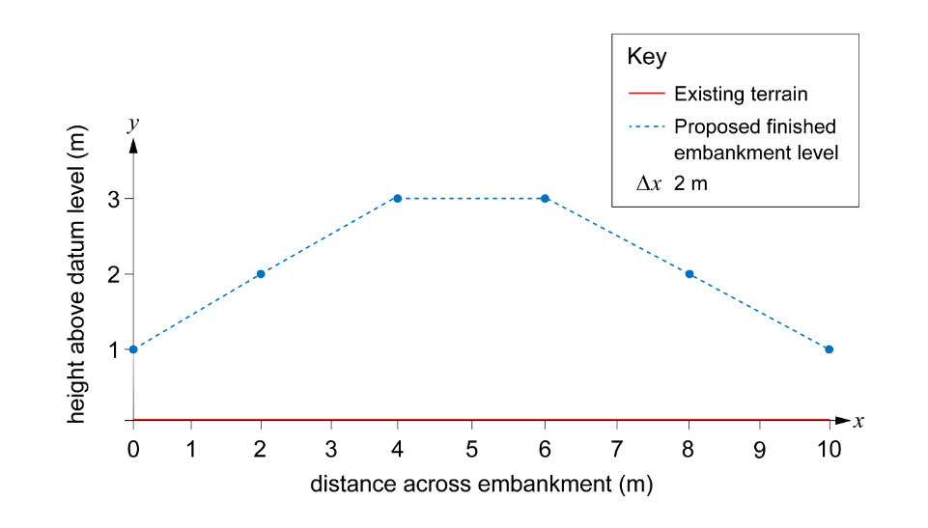
Remember to work through each step in turn.
Step 1: Plot the ‘x’ and ‘y’ co-ordinates on graph paper.
Step 2: Divide the base width of the cross-section into equal intervals. (5 would be a good choice)
Step 3: Determine the midpoint of each interval.
Step 4: Measure the height of the fill at each point.
Step 5: Calculate the area of each interval.
Step 6: Add up the areas of the segment to get the total area of the cross-section.
Step 7: Work out the total amount of material needed by multiplying the area of the cross-section by the length of the embankment.

Practice question 2
Using the mid-ordinate rule to calculate the cross-sectional area of another road embankment with a base width of 12 metres divided into six equal segments. The heights are as given in the table below.
You can assume that the existing ground level is at 0 metres.
Position (m) | Proposed height (m)
0 | 2.5
2 | 3.0
4 | 5.0
6 | 5.0
8 | 5.0
10 | 3.0
12 | 2.5
Hint: Remember to work through each step in turn, starting by sketching the embankment. Embankments are an engineered structure; they have level tops and slopes which are graded to a specified angle, so you can plot this graph by joining the heights at each position with a straight line.

Practice question 3
You are designing a road that must pass through uneven terrain. To create a level road, you will need to cut soil from higher areas and fill soil to lower areas. The cross-section of the terrain along a 10-metre stretch of road is given in the table and graph below.
Use the mid-ordinate rule to calculate how much material will need to be removed from site to create a suitable road. The road will be 9 metres wide.
Position (m) | Existing elevation (m) | Desired elevation (m)
0 | 3.5 | 3.0
2 | 3.0 | 3.0
4 | 3.5 | 3.0
6 | 3.5 | 3.0
8 | 2.5 | 3.0
10 | 2.0 | 3.0

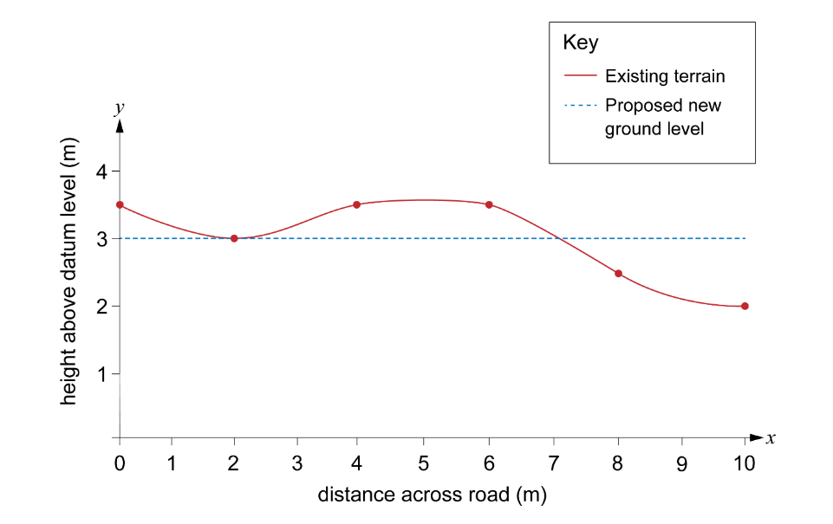
Hint: Remember to add in the proposed road level. You will need this to work out the areas of cut and fill.

