Consolidation
This worksheet provides practice in finding the area under a curve using integration.

Question 1
The graph below shows the curve $y= 4x- x^{2}$.
Calculate the area under the curve.
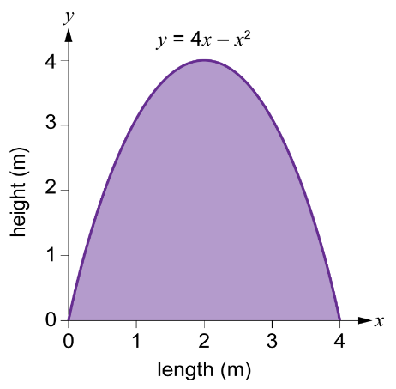

Question 2
The graph below shows the curve $y= x^{2}-6x$.
Calculate the area between the curve and the x-axis.
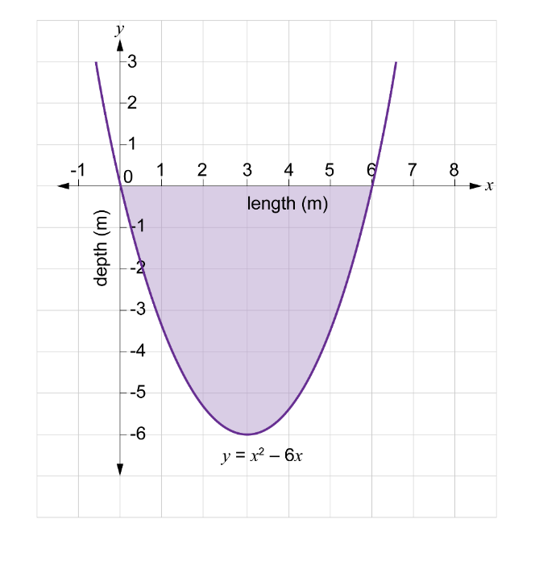

Question 3
The graph below shows the curve $y=-1.002x^{2}+20.02x+0.0019$.
Calculate the area under the curve.
