**Activity 1 Worksheet (scaffolded): Using integration to calculate the area under a curve**

# Practice question 1A large, arched opening made of white brick in a wall.

As part of some renovation work, a contractor needs to fill in an old arched opening to create an internal room. You have been asked to use integration to check the overall area so that eventually it will be possible to determine the number of stone blocks that will be needed.

The arched part of the graph can be represented by the quadratic equation:

$$y= -0.25x^{2}+2.22x+2.$$

**Image © Shutterstock/Olena Kozachuk**

**Image © Shutterstock/Olena Kozachuk**

This graph is shown below.

**Figure 1**

**Step 1: Integrate each term.**

$$y= -0.25x^{2}+2.22x+2$$

$$Area=\int_{0}^{9}{}-0.25x^{2}+2.22x+2 dx$$

$$Area= {\left[-\frac{ }{3}x^{3}+\frac{ }{2}x^{2}+________\right]}_{0}^{9}$$

$$Area= {\left[-__________x^{3}+_________x^{2}+_________\right]}_{0}^{9}$$

**Step 2: Apply definite limits.**

To find the area, we need to evaluate the integral at each limit, $x = 9$ and $x = 0$, and find the difference.

At $x=9$

$$-0.0833{\left(______\right)}^{3}+1.11{\left(_______\right)}^{2}+2\left(_______\right)=___________$$

At $x=0$

$$__________________________________________=____________$$

This means that the integration calculation is:

$$Area= _________-__________$$

$$Area= _________________m^{2}$$

# Practice question 2

You are tasked with cladding the back elevation of a metal hangar.   
The back elevation of the hangar has a curved shape. The total width of the hangar’s side is 36 metres.

The arch shape can be represented by the quadratic equation:

$y= -0.019x^{2}+0.7x+3$.

The graph is shown below.

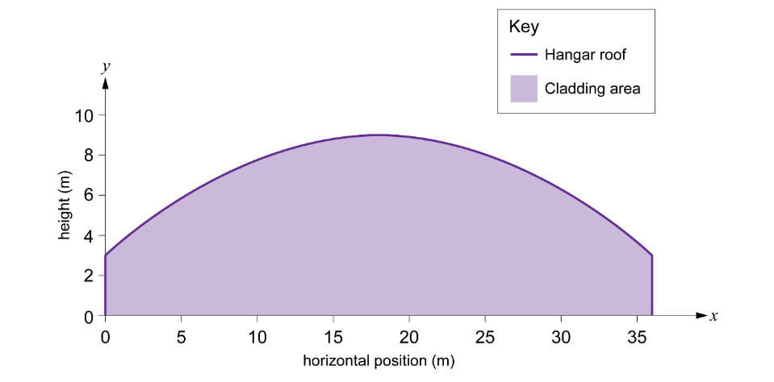**Figure 2**

**Step 1: Integrate each term.**

$$y= -0.019x^{2}+0.7x+3$$

$$Area=\int_{0}^{36}{} -0.019x^{2}+0.7x+3 dx$$

$$Area= {\left[ \right]}_{0}^{36}$$

**Step 2: Apply definite limits.**

To find the area, we need to evaluate the integral at each limit, $x = 9$ and $x = 0$, and find the difference.

At $x=36$

At $x=0$

This means that the integration calculation for the area is:

$$Area= _________________{ m}^{2}$$