Activity 1 Worksheet: Using integration to calculate the area under a curve

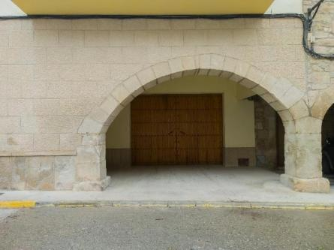
Practice question 1
As part of some renovation work, a contractor needs to fill in an old arched opening to create an internal room. You have been asked to use integration to check the overall area so that eventually it will be possible to determine the number of stone blocks that will be needed.
The arched part of the graph can be represented by a quadratic equation in the form and is shown below.
Image © Shutterstock/Olena Kozachuk
$$y= -0.25x^{2}+2.22x+2.0$$
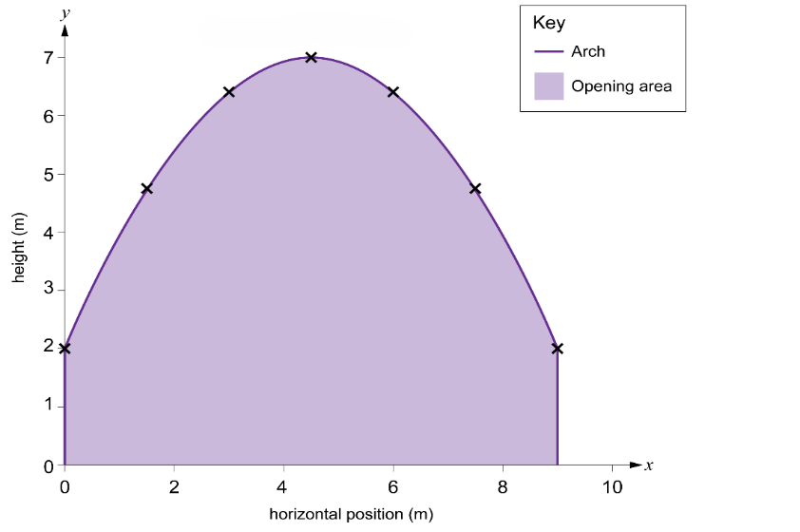
Figure 1
The area under the curve between $x$ = 0 m and $x$ = 9 m is to be determined. So:
$$Area= \int_{0}^{9}{}\left(-{0.25x}^{2}+2.22x+2.0\right) dx$$
Remember to work through the steps in turn:
Step 1: Integrate each term.
Step 2: Apply definite limits.
Step 3: Evaluate at highest value of x.
Step 4: Evaluate at lowest value of x.
Step 5: Calculate the final area.

Practice question 2
You are tasked with cladding the back elevation of a metal hangar. The back elevation of the hangar has a curved shape, and its dimensions are provided in the graph below. The total width of the hangar’s side is 36 metres. The arched part of the graph can be represented by a quadratic equation in the form:
$$y= -0.019x^{2}+0.7x+3.0$$
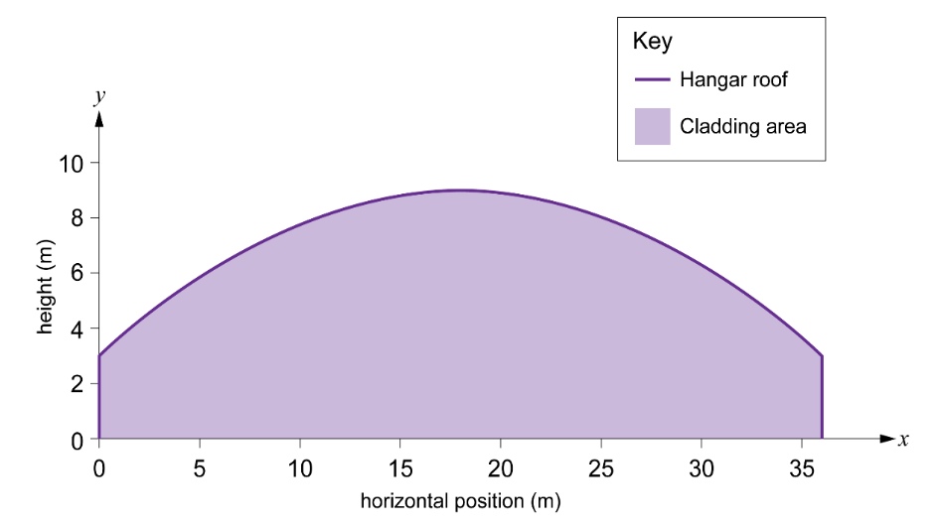
Figure 2
The area under the curve between $x$ = 0 m and $x$ = 36 m is to be determined. So:
$$Area= \int_{0}^{36}{}\left(-{0.019x}^{2}+0.7x+3.0\right) dx$$

