Using integration to calculate the area under a curve

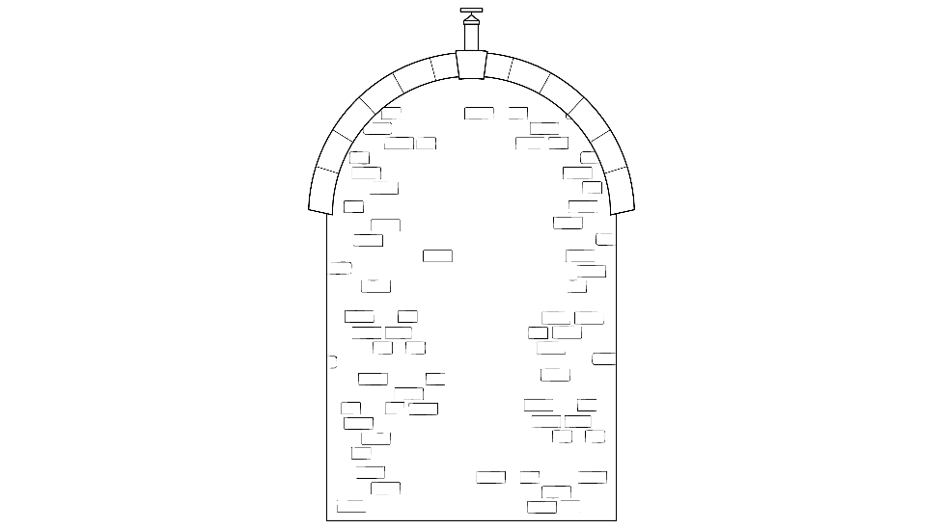
Worked example
You are constructing a new roof for a factory similar in shape to that shown in Figure 1. You need to calculate the area of brickwork that will be required to fill under the arch.
The proportions and roof line for an arch for the new building are shown in Figure 2 below and can be represented by the quadratic equation:
Figure 1
Figure SEQ Figure \* ARABIC 1: The factory roof line
$$y=- 0.2x^{2}+4x$$
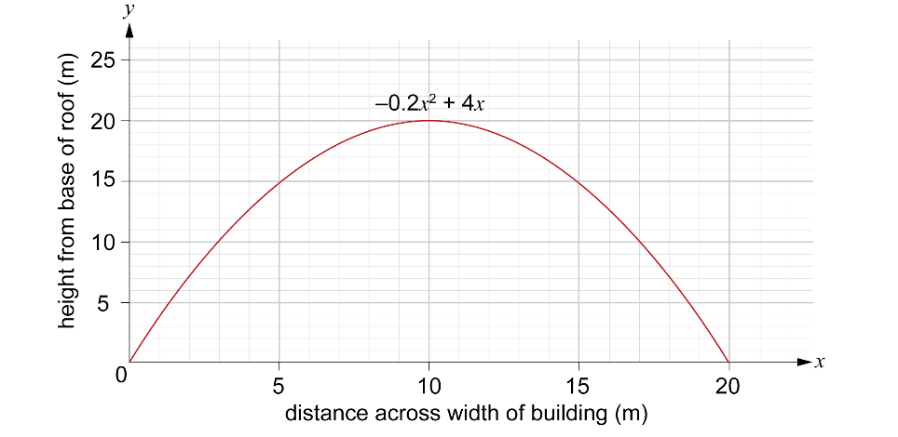
Figure 2: The proportions and roof line of the proposed building
The area, $A$, under the curve between $x=0 m$ and $x=20 m$ is to be determined.
We can write this as an integration calculation:
$$A= \int_{0}^{20}{}\left(-{0.2x}^{2}+4x\right)dx$$
Step 1: Integrate each term.
When we have limits, it’s a definite integral. We use square brackets and add the limits to the top and bottom of the bracket.
Remember: When integrating, you add 1 to the power and divide by the new power.
$$A= \int_{0}^{20}{}\left(-{0.2x}^{2}+4x\right)dx$$
$$A= {\left[\frac{-0.2}{3}x^{3}+\frac{4}{2}x^{2}\right]}_{0}^{20}$$
$$A= {\left[-0.067 x^{3}+2x^{2}\right]}_{0}^{20}$$
Step 2: Apply definite limits.
To find the area, we need to evaluate the integral at each limit, $x = 20$ and $x = 0$, and find the difference.
At $x = 20$:
$$-0.067 {\left(20\right)}^{3}+2{\left(20\right)}^{2}=-0.067\left(8000\right)+2\left(400\right)=-536+800=264$$
At $x = 0$:
$$-0.067 {\left(0\right)}^{3}+2{\left(0\right)}^{2}=-0.067\left(0\right)+2\left(0\right)=0$$
This means that the integration calculation is:
$$A= {\left[-0.067 x^{3}+2x^{2}\right]}_{0}^{20}$$
$$A= 264-0$$
$$A= 264 m^{2}$$

So, enough bricks will need to be purchased to cover an area of 264 m².

