**Consolidation: answers**

# Practice question 1

**Step 1: Define the variables.**

Let $x$ represent the horizontal side and *y* represent the vertical side of the compound diagram.

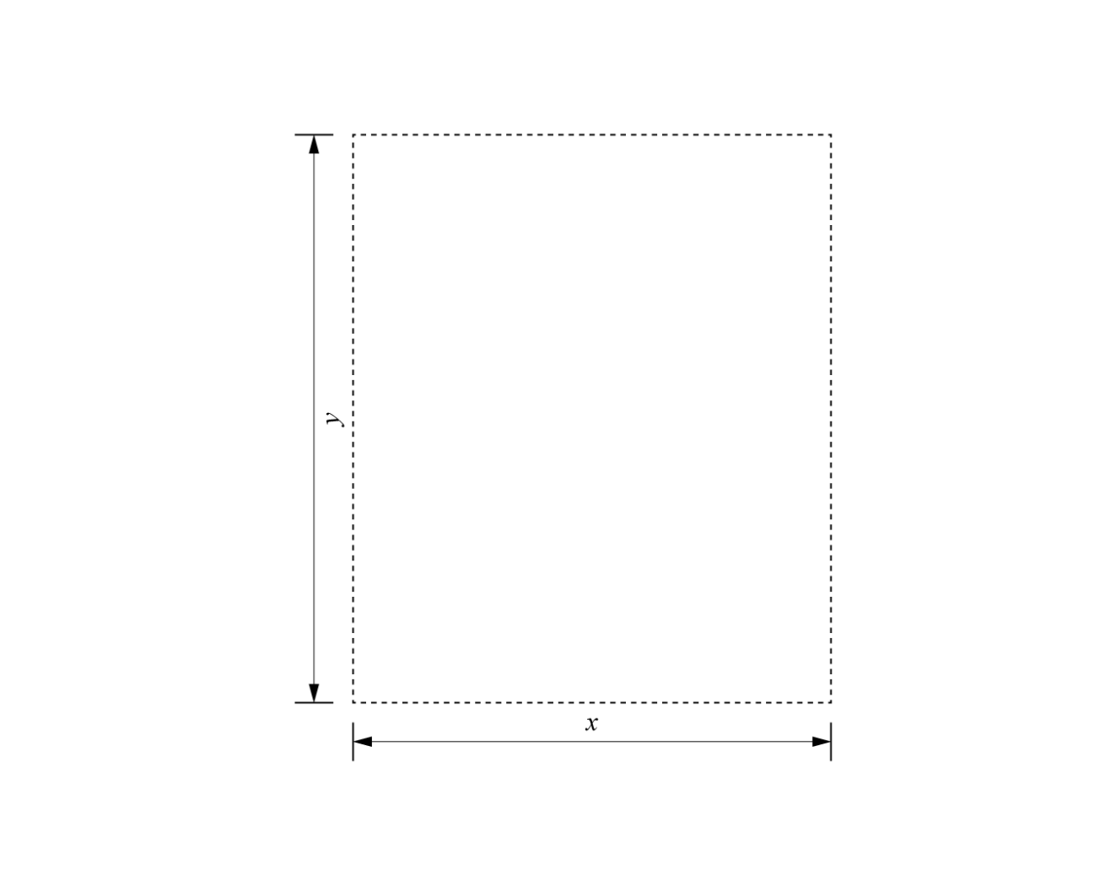

The total area of the site is 8000 m2, so:

Express $y$ in terms of $x$:

$$y= \frac{8000}{x}$$

**Step 2: Write an equation for the cost of fencing in terms of $x$.**

The vertical sides (length $y$) cost £20 per metre. The horizontal sides (length $x$) cost £30 per metre. So, the total cost of fencing is:

$$C=\left(2 ×30x\right)+\left(2 × 20y\right)=60x+40y$$

Substitute the formula for $y$ into the cost equation:

$$C=60x+40 \left(\frac{8000}{x}\right)$$

$$C=60x+ \frac{320,000}{x}$$

**Step 3: Differentiate to minimise $C$.**  
Differentiate *C* with respect to $x$:

$$C=60x+ \frac{320,000}{x}$$

$$\frac{dC}{dx}= 60- \frac{320,000}{x^{2}}$$

Now we need to find $x$. Set the derivative equal to 0:

$$60- \frac{320,000}{x^{2}}=0$$

$$\frac{320,000}{x^{2}}=60$$

$$x^{2}= \frac{320,000}{60}$$

$x^{2}= 5333.33$ 3

$x = \sqrt{5333.333}=73.03$ m

**Step 4: Check it’s a minimum.**

Find the second derivative:

$$\frac{dC}{dx}= 60- \frac{320,000}{x^{2}}$$

$$\frac{d^{2}C}{dx^{2}}= \frac{640,000}{x^{3}}$$

Substitute $x=73.03:$

$$\frac{d^{2}C}{dx^{2}}= \frac{640,000}{{(73.03)}^{3}}=1.643…$$

The second derivative is greater than 0, so this is a minimum.

**Step 5: Find the dimensions and the total cost.**

$$x = 73.03 m$$

Substitute $x$ into the formula for $y$:

$y= \frac{8000}{73.03}=109.54 m$

Calculate the total cost:

Substitute $x=73.03$ and $y=109.54 m$ into the cost equation:

$$C=60x+40 y$$

$$C=60(73.03)+40 (109.54)$$

$$C=4381.80+4381.60=£8763.20$$

The minimised cost of the fencing is £8763.20.

The dimensions of the compound are length 73.03 metres and width 109.54 metres.

# Practice question 2

Let $y$ represent the vertical side and *x* represent the horizontal side of the compound.

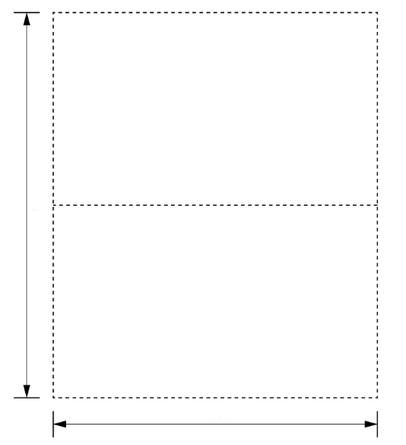

*y*

*x*

**Step 1: Define the variables.**

The total area of the site is 9000 m2, so:

Express $x$ in terms of $y$:

$$x= \frac{9000}{y}$$

**Step 2: Write an equation for the total length of fencing in terms of $x$.**

There are 2 sides of length $y$, 2 sides of width $x$ and 1 dividing fence along $x$.

The total length of fencing for the site is:

$$L=2y+3x$$

Substitute $x$ into the length equation:

$$L =2y+3\left(\frac{9000}{y}\right)$$

$$L =2y+ \frac{27000}{y}$$

**Step 3: Differentiate to minimise $L$.**

Differentiate $L$ with respect to $y$.

$$L =2y+ \frac{27,000}{y}$$

$$\frac{dL}{dy}= 2- \frac{27,000}{y^{2}}$$

Now we need to find $x$. Set the derivative equal to 0:

$$2- \frac{27,000}{y^{2}}=0$$

$$\frac{27,000}{y^{2}}=2$$

$$y= \frac{27,000}{2}$$

$$y^{2}= 13,500$$

$y = \sqrt{13,500}=116.19$ m

**Step 4: Check it’s a minimum.**

Find the second derivative:

$$\frac{dL}{dy}= 2- \frac{27,000}{y^{2}}$$

$$\frac{d^{2}C}{dy^{2}}= \frac{54,000}{y^{3}}$$

Substitute $y=116.19:$

$$\frac{d^{2}C}{dy^{2}}= \frac{27,000}{{(116.19)}^{3}}=0.017…$$

The second derivative is greater than 0, so this is a minimum.

**Step 5: Find the final dimensions:**

$$y = 116.19 m$$

Substitute $y$ into the formula for $x$:

$x= \frac{9000}{116.19}=77.46$ m

Calculate the total fencing length:

$$L=2(116.19)+3(77.46)$$

$$L=232.38+232.38$$

$L=464.76$ m

The dimensions of the compound to minimise the total fencing length are height 116.19 metres and width 464.76 metres.