Calculating heat loss through a wall

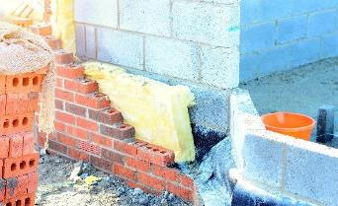
Worked example
A typical cavity wall consists of two layers (or leaves) of masonry with a gap (cavity) between them. The materials used in each layer and the cavity itself have different thermal resistances.
The common makeup of a cavity wall consists of:
Image © Shutterstock/Irene Miller
Material | Thermal resistance, $R$, (in m² K/W)
100 mm clay brick | 0.18
50 mm air gap | 0.18
50 mm expanded polystyrene board | 1.25
100 mm concrete block | 0.15
Outside surface resistance | 0.06
Inside surface resistance | 0.12
Calculate the heat loss by 1 m² of this wall when the temperature difference either side of the wall is 10°C.
U-value
$$U=\frac{1}{R}$$
where R is the thermal resistance
For this cavity wall, the thermal resistance is
$$R = 0.18 + 0.18 + 1.25 + 0.15 + 0.06 + 0.12 = 1.94$$
U-value for the cavity wall:
$U= \frac{1}{R}= \frac{1}{1.94}=0.515$ W/m²K

Rate of heat loss
Heat loss:
$$Q=U A ΔT$$
The temperature difference from one side of the cavity wall to the other was 10°C, or 10 K. The heat loss for 1 m² of this cavity wall would be:
$$Q =U A ΔT$$
$$Q=0.515×1×10$$
$$Q=5.15 Watts$$

