Activity 4: Skin assessment practical –
Skin assessment form

Scenario 1:
Patient information
Name:………………………………..
Date:……………… Time:………..

Body map
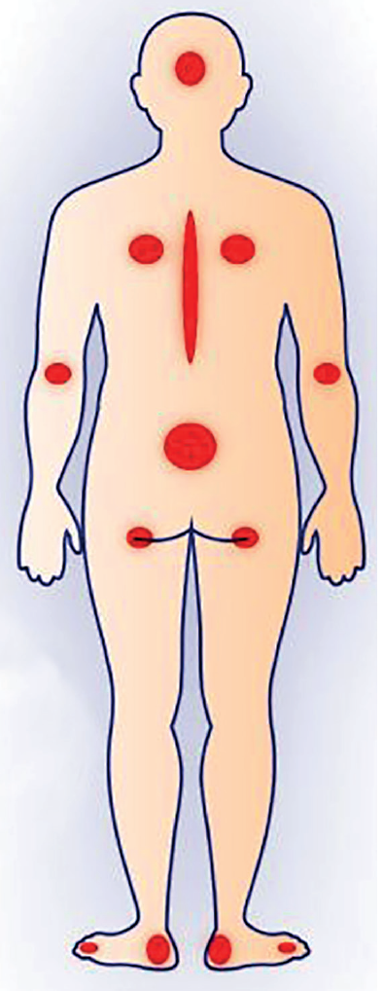
Scenario 2:
Patient information
Name:………………………………..
Date:……………… Time:………..

Body map

