**Activity: Classifying pressure injuries answers**

**Image 1:**

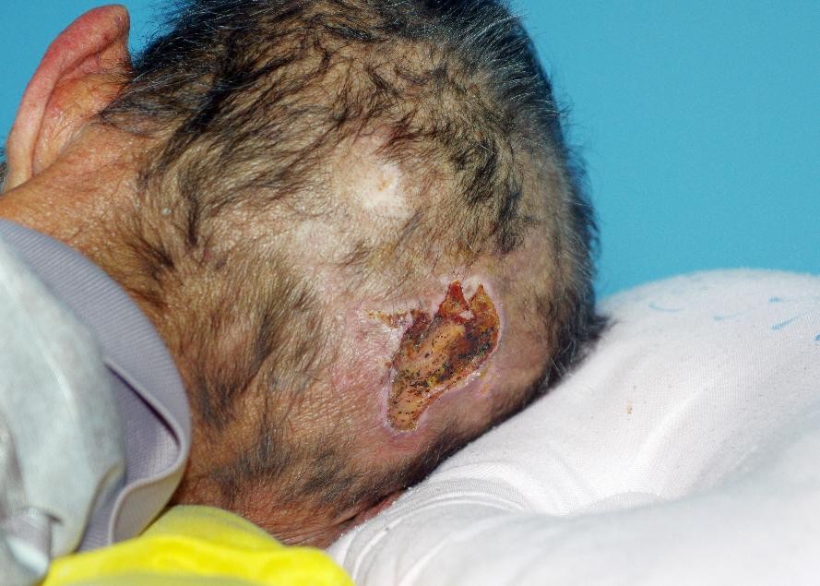

*Image © Shutterstock/phichet chaiyabin*

**Answer:**

Category 4 ulcer – full-thickness tissue loss. There is exposed bone due to the back of head location. There is little subcutaneous tissue and therefore this ulcer is quite shallow.

**Image 2:**

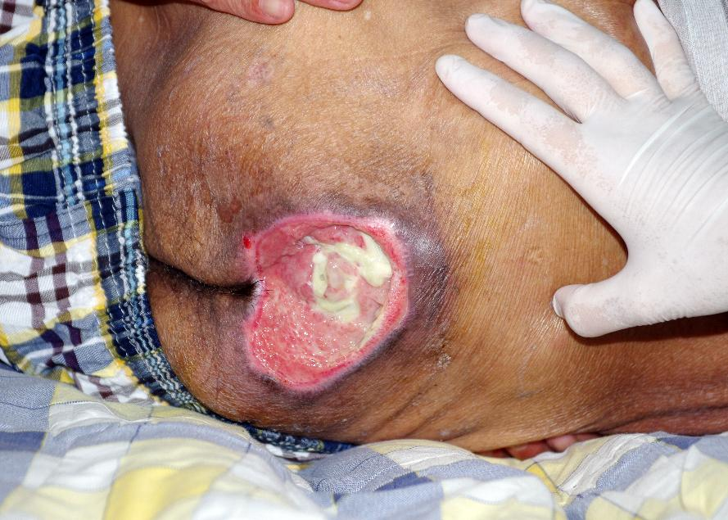

*Image © Shutterstock/phichet chaiyabin*

**Answer:**

Category 4 – full-thickness tissue loss. There appears to be bone visible in the middle of the green sloughy area. Lower back. Also, note there is possible undermining in the skin close to the thumb area.

**Image 3:**

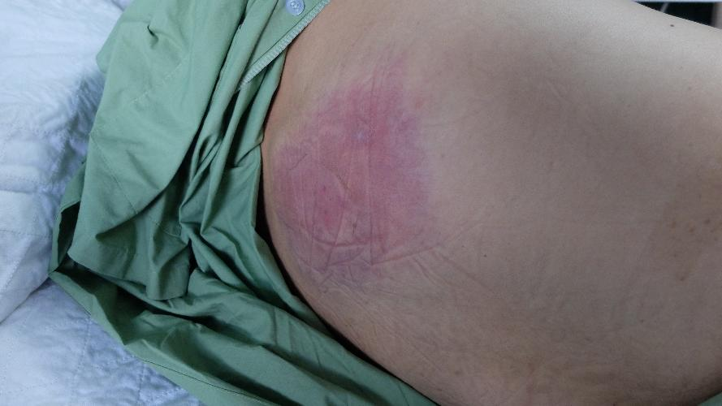

*Image © Shutterstock/Casa nayafana*

**Answer:**

Category 1 – non-blanchable erythema. Unclear location – possibly high buttock. This could have been caused by a fall and lying in one position for some time.

**Image 4:**

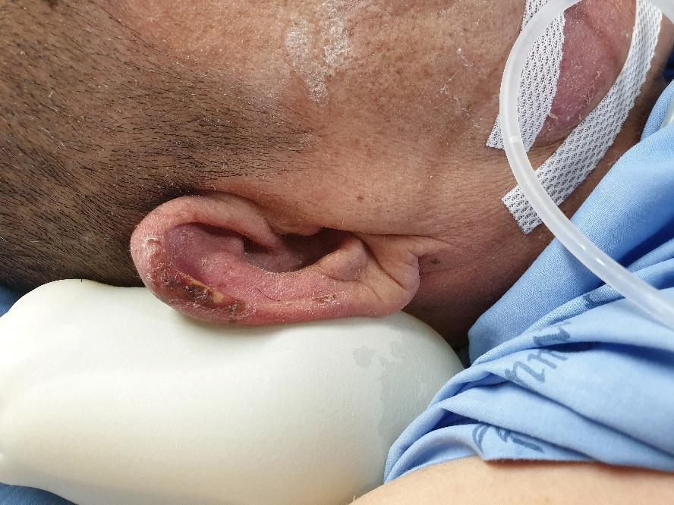

*Image © Shutterstock/Rojchana Loonrasri*

**Answer:**

Category 3 or 4 – the darker areas look like necrotic tissue and therefore this would be initially graded as Category 3. However, if the wound was to be debrided (where dead skin is removed either through dressings, Lavae therapy [maggots] or physically cut away) and appears to have full thickness tissue loss, it would be reclassified to Category 4. Location – ear.

**Image 5:**

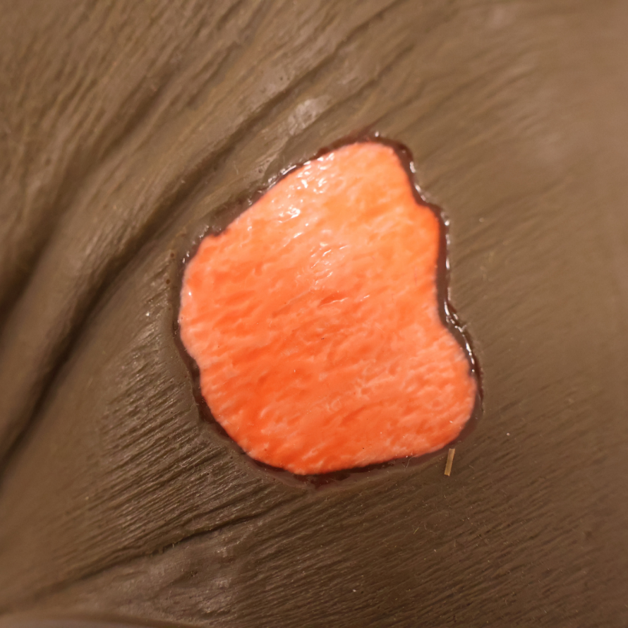

*Image © Sims & Skills Ltd*

**Answer:**

Category 2 pressure ulcer. The wound is located on a surface with skin folds and texture consistent with the buttocks or sacral area, which are common sites for pressure ulcers due to prolonged sitting or lying down.

**Image 6:**

*Image © University Hospitals Bristol and Weston NHS Foundation Trust, Reframe Image Library*

**Answer:**

Category 1 pressure injury on the forehead, likely caused by prolonged pressure from medical devices such as ventilation tubing or securement straps. The skin appears discoloured but intact.

Device-related pressure injuries are common in neonatal intensive care and require careful monitoring, frequent repositioning, and protective dressings to prevent progression.

**Image 7:**

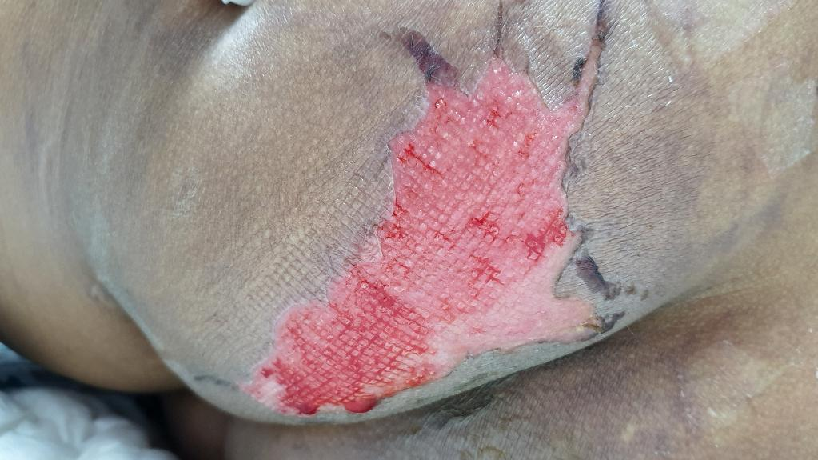

*Image © Shutterstock/RJ22*

**Answer:**

Category 2 with a pink/red wound bed. Unclear location on body. No slough present. It appears to be healing.

**Image 8:**

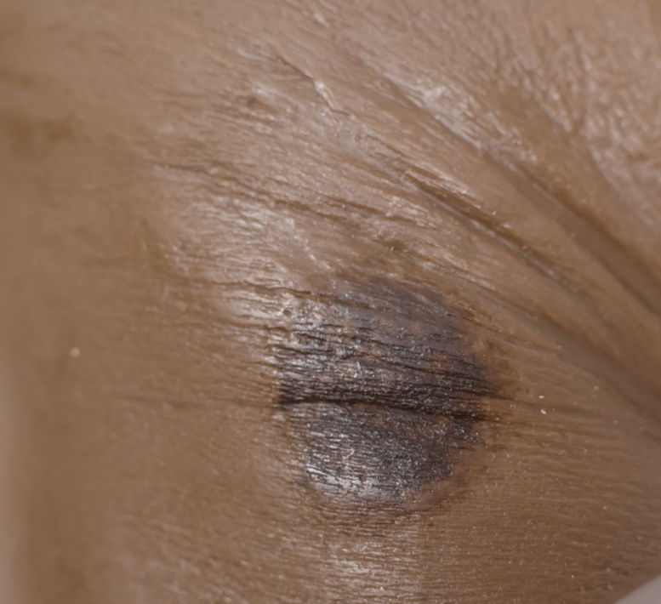

*Image © Sims & Skills Ltd*

**Answer:**

Category 1 pressure sore, located on an area with visible skin creases, possibly in the buttock area. The skin is intact but shows a localised area of dark discoloration, consistent with pressure damage. Early intervention is critical to prevent progression to deeper stages.