**Activity: Classifying pressure injuries**

**Image 1:**

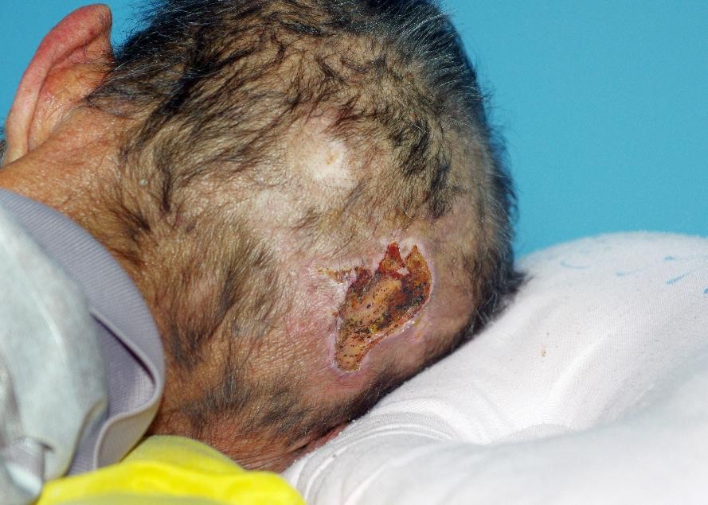

*Image © Shutterstock/phichet chaiyabin*

**Image 2:**

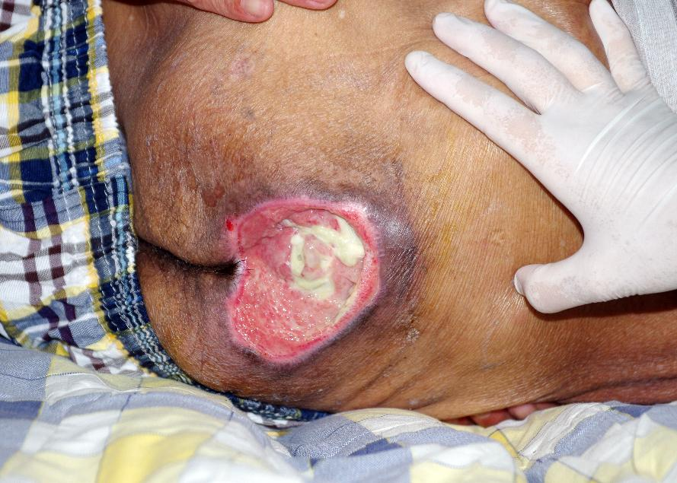

*Image © Shutterstock/phichet chaiyabin*

**Image 3:**

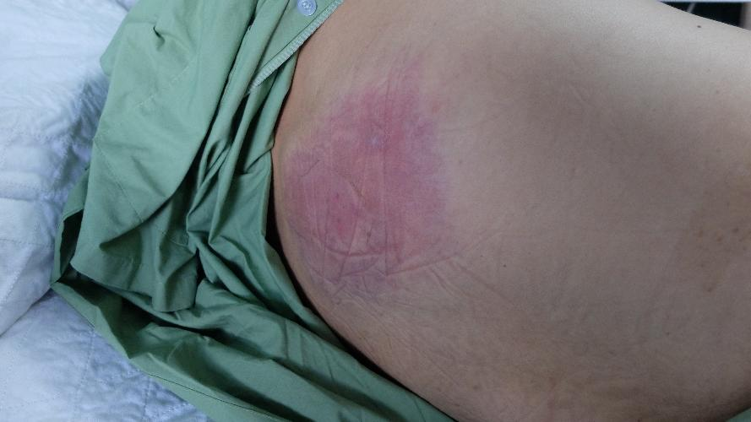

*Image © Shutterstock/Casa nayafana*

**Image 4:**

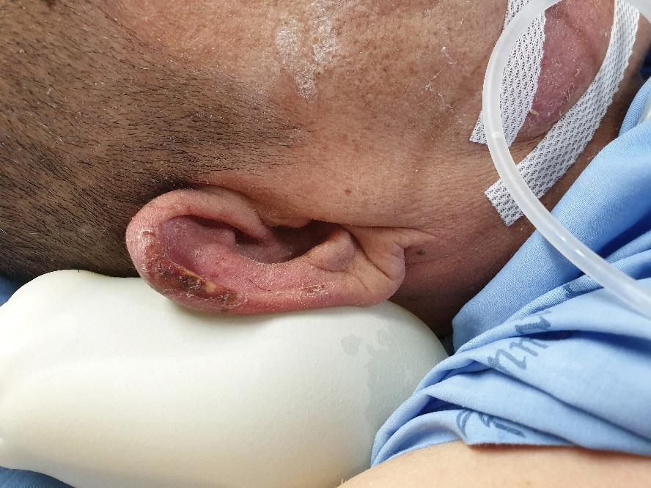

*Image © Shutterstock/Rojchana Loonrasri*

**Image 5:**

*Image © Sims & Skills Ltd*

**Image 6:**

*Image © University Hospitals Bristol and Weston NHS Foundation Trust, Reframe Image Library*

**Image 7:**

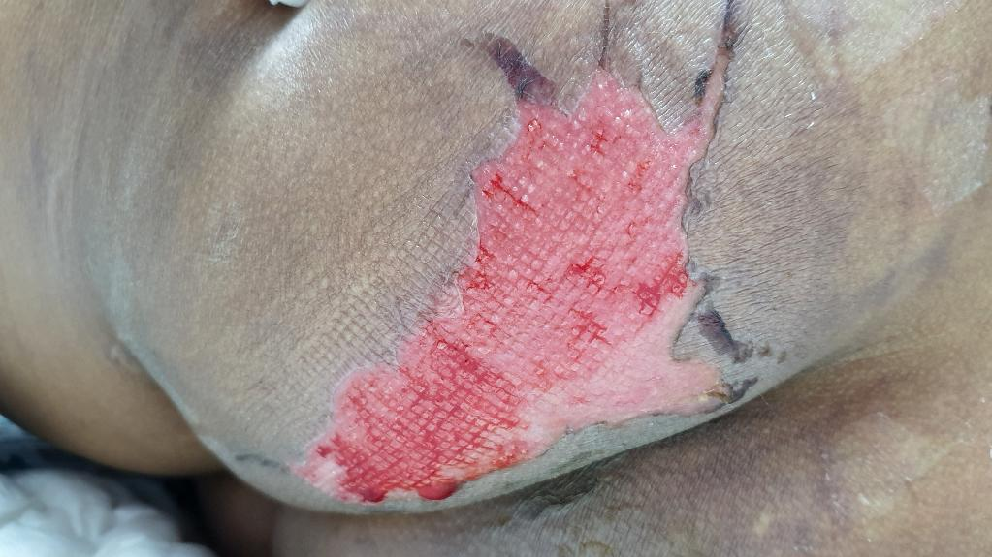

*Image © Shutterstock/RJ22*

**Image 8:**

*Image © Sims & Skills Ltd*