Activity 1: Skin structure and function
1. Complete the empty labels detailing the cross-section of the skin.

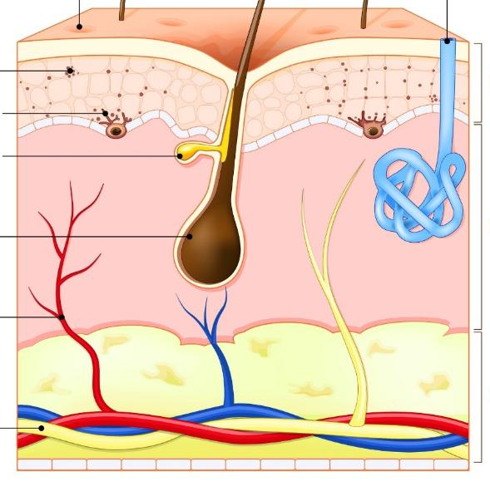

Image © Shutterstock/Designua
2. Summarise the structure and function of the three layers of skin.
Epidermis:

Dermis:

Hypodermis/subcutaneous layer:

