**Activity 1 Case study: Agreeing work in progress on site**

**Read the Activity 1 Case study below. In pairs, role play the discussion which might take place between the quantity surveyor’s assistant and the contractor.**

You have been tasked with supporting the main quantity surveyor in the on-site measuring of ongoing work. A monthly valuation has been submitted by a subcontractor during the building of new homes. Currently, the subcontractor is constructing cavity walls and has claimed 150 m2 of completed wall area. According to the BoQ agreed upon at the project's award stage, the rate for this work is £132.15 per m2. Based on this claim, the subcontractor has requested £19,822.50 for this aspect of the work.

Upon arriving on site, it becomes apparent that not all of the claimed wall area has been completed. Working alongside the main quantity surveyor, you conduct an independent measurement using a tape measure and determine that only 110 m2 of the wall has been finished.

Following this assessment, you hold a meeting with the subcontractor to review the extent of the work completed for the month. During the discussion, you highlight the over-claim for the brickwork and propose a revised figure of £14,536.50, reflecting the actual completed work of 110 m2.

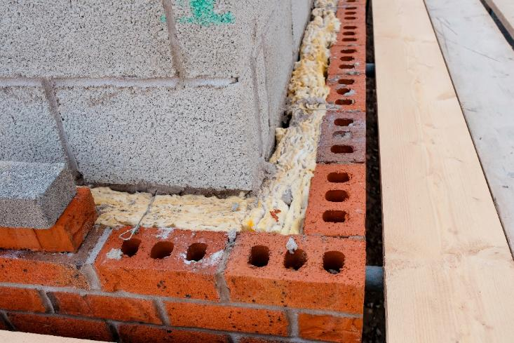

*A close-up photograph of the cavity wall showing the half brick   
stretcher bond and the cavity wall ties.*

Image © Shutterstock/Irene Miller

**Example of part of a BoQ**

|  |  |  |  |  |  |
| --- | --- | --- | --- | --- | --- |
| **Gatsby Quantity Surveyors Limited**, Leeming Place, Norwich, NR1 4AB | | | | | |
| Page of BoQ (1 of 30) and section of works (External Walls) | | | | | |
| **Item** | **Description** | **Quantity** | **Unit** | **Rate** | **Total** |
|  | BRICKWORK |  |  |  |  |
|  | Facing Brickwork |  |  |  |  |
| (a) | Half brick thick laid in stretcher point and pointed using (1:1:6) mortar | 150 | m2 | £132.15 | £19822.50 |
|  | Cavities |  |  |  |  |
| (b) | Form cavity in hollow wall with stainless steel vertical twist ties 4 per m2 | 147 | m2 | £2.45 | £367.50 |