**Activity 2: The cell cycle**

This diagram shows the stages in the cell cycle.

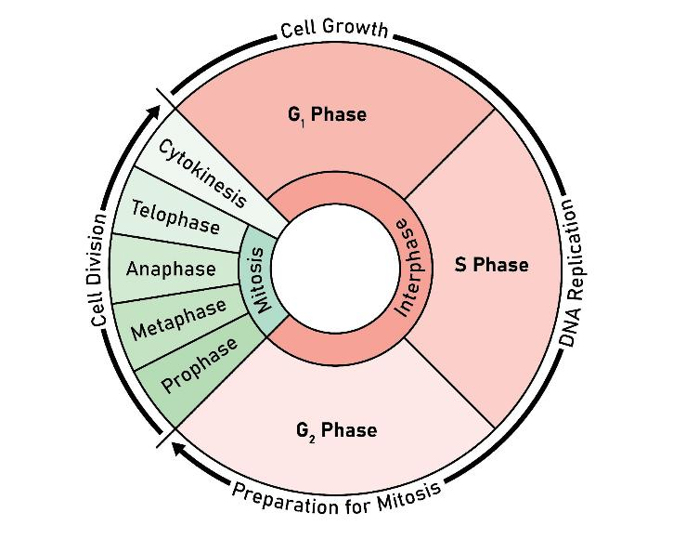

Image © Shutterstock/Kooto

1. For each description below, write the name of the stage being described.

|  |  |
| --- | --- |
| **Name of stage** | **Description** |
|  | The cell grows, produces proteins and prepares for DNA replication. |
|  | DNA is replicated, creating two identical copies for the daughter cells. |
|  | The cell prepares for mitosis, checking for DNA integrity and errors. |
|  | DNA is copied. |
|  | The cell divides into two identical daughter cells. |

**Checkpoints and genes**

* At the end of each stage there is a checkpoint to make sure the cell is ready for the next stage.
* The p53 gene detects DNA damage so the cell can pause for repairs.
* DNA repair genes help correct errors in the DNA.
* p53 can trigger apoptosis (cell death) if the damage is too severe.
* Proto-oncogenes are genes that promote controlled cell growth and division.

1. A change in a gene (a mutation) can cause a cell to become cancerous. Use what you have learned from completing this activity to suggest the different reasons why.