**Activity 2: Cancer profile**

Decode medical terms:

Acute:

Myeloid:

Leukaemia:

|  |
| --- |
| **Name of cancer:** Acute myeloid leukaemia (AML) |
| **Context of cancer:** AML is an aggressive cancer of specific white blood cells called myeloid cells. |
| **Age of onset:** The risk of developing AML increases with age. It's most common in people over 75. |

|  |
| --- |
| **Causes:** Stem cells in bone marrow produce too many immature white blood cells called blast cells. These cells cannot fight infections like a normal white blood cell and their overproduction leads to a decrease in red blood cells. |
| **Risk factors:** Previous chemotherapy or radiotherapy, having an underlying blood disorder or genetic disorder e.g. Down’s syndrome, exposure to benzene or cigarette smoke, increasing age. |
| **Symptoms:** Pale skin, tiredness, breathlessness, frequent infections, unusual and frequent bleeding e.g. nosebleeds, losing weight. |
| **Treatment:** Chemotherapy to kill the leukaemia cells and bone marrow or stem cell transplant to achieve a cure. |

**Pictures:**

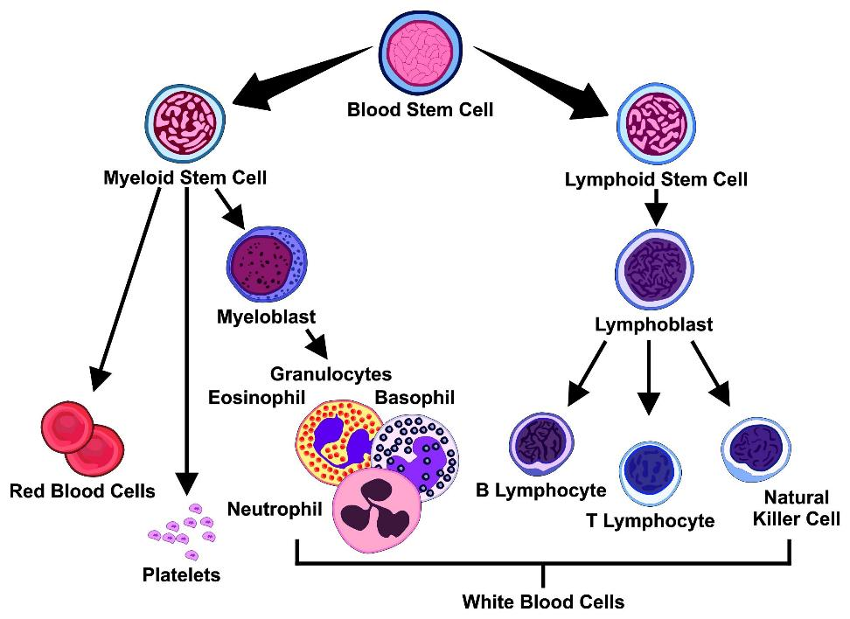

Image © Shutterstock/udaix

**References:**

www.nhs.uk/conditions/acute-myeloid-leukaemia