**Teacher support: Reflux setup errors**

Set up the apparatus as shown below and use a whole class discussion to elicit the errors, any consequences or problems that may arise from leaving the setup as it is (safety issues, solvent/product loss, lower yield, etc.), and how the error can be corrected. As the errors are spotted and corrected, make those suggested changes to the setup.

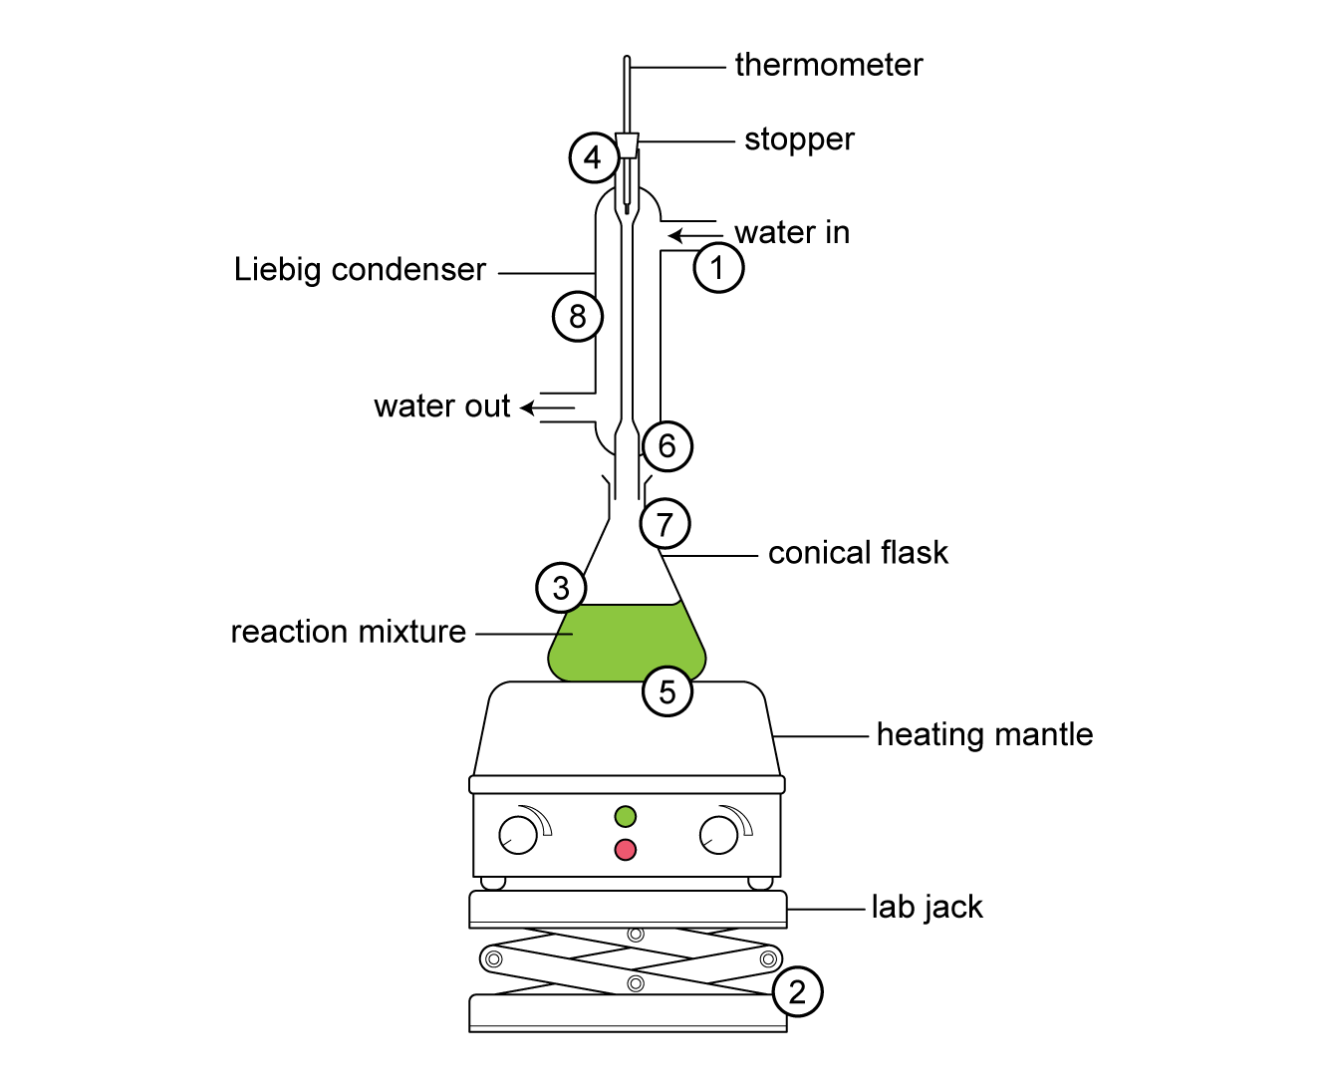

Errors to use in this setup:

1. The condenser water inlet and outlet are the wrong way round.
2. The lab jack flat on the desk is missing.
3. A conical flask/pear-shaped flask used with a hotplate/poorly fitting heating mantle.
4. The setup is a closed system with a stopper in the top, either with or without a thermometer.
5. No anti-bumping granules in the reaction vessel.
6. Loose/incorrectly attached connection between flask and condenser.
7. Flask is more than half filled.
8. No clamp on the flask.