End-of-unit assessment

1. Explain **one** advantage of using volumetric construction.

(2)

……………………………………………………………………………………………………………………………………………………………………………………………

……………………………………………………………………………………………………………………………………………………………………………………………

……………………………………………………………………………………………………………………………………………………………………………………………

……………………………………………………………………………………………………………………………………………………………………………………………

2. Figure 1 shows a section of a SIP.

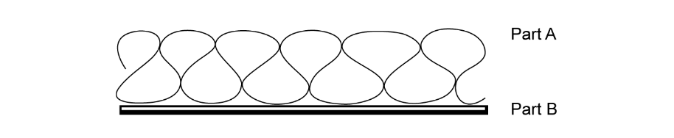

**Figure 1**

a) State what is meant by the initials SIP.

(1)

……………………………………………………………………………………………………………………………………………………………………………………………

b) Name the parts labelled A and B on Figure 1.

(2)

Part A…………………………………………………………………………………………………………………………………………………………………………

Part B…………………………………………………………………………………………………………………………………………………………………………

3. Give **two** advantages of using panelised sections in the construction industry. (2)

………………………………………………………………………………………………………………………………………………………………………………………

……………………………………………………………………………………………………………………………………………………………………………………………

……………………………………………………………………………………………………………………………………………………………………………………………

………………………………………………………………………………………………………………………………..…………………………………………………………

4. This figure shows an orthographic drawing of the front and side elevation of a modular construction.

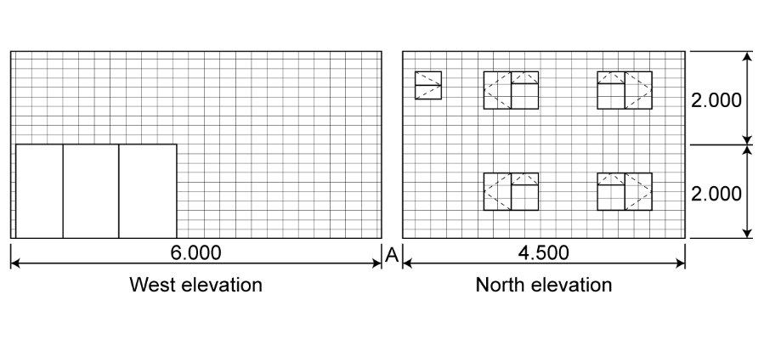

All dimensions are in metres.

Draw an isometric sketch of the modular construction.   
Your teacher will provide you with isometric paper. (9)

5. Figure 2 shows a small construction site cleared and levelled.

Planning permission has been granted to build 22 houses comprising of shared ownership and homes for rent. The site is on the edge of a completed housing development of over 500 homes, but it has limited road access and on-site parking. The build programme is 12 months.

The developer is considering using one of two modern methods of construction:

* volumetric construction techniques *or*
* the use of SIP panels.

Evaluate the two construction methods being considered and produce a justified recommendation for the developer.

(12)

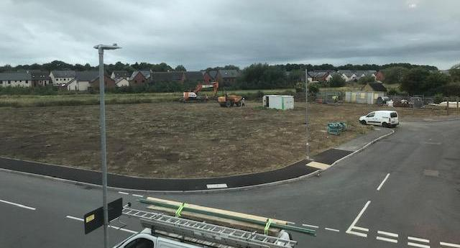

**Figure 2**

………………………………………………………………………… ………………………………………………………………………………………………………………..

……………………………………………………………………………………………………………………………………………………………………………………………

……………………………………………………………………………………………………………………………………………………………………………………………

………………………………………………………………………………………………………………………………………………………………………………………….

……………………………………………………………………………………………………………………………………………………………………………………………

……………………………………………………………………………………………………………………………………………………………………………………………

……………………………………………………………………………………………………………………………………………………………………………………………

……………………………………………………………………………………………………………………………………………………………………………………………

……………………………………………………………………………………………………………………………………………………………………………………………

……………………………………………………………………………………………………………………………………………………………………………………………

……………………………………………………………………………………………………………………………………………………………………………………………

……………………………………………………………………………………………………………………………………………………………………………………………

……………………………………………………………………………………………………………………………………………………………………………………………

……………………………………………………………………………………………………………………………………………………………………………………………

……………………………………………………………………………………………………………………………………………………………………………………………

……………………………………………………………………………………………………………………………………………………………………………………………

……………………………………………………………………………………………………………………………………………………………………………………………

……………………………………………………………………………………………………………………………………………………………………………………………

……………………………………………………………………………………………………………………………………………………………………………………………

……………………………………………………………………………………………………………………………………………………………………………………………

……………………………………………………………………………………………………………………………………………………………………………………………

……………………………………………………………………………………………………………………………………………………………………………………………

……………………………………………………………………………………………………………………………………………………………………………………………

……………………………………………………………………………………………………………………………………………………………………………………………

……………………………………………………………………………………………………………………………………………………………………………………………

……………………………………………………………………………………………………………………………………………………………………………………………