Activity 1: Worksheet 1

How to assess risk
Wherever you are and whatever you are doing, there is the chance that you may cause yourself harm or injury. We learn to be aware when something has the potential to cause us harm in everyday life, but what about in a laboratory?

Identifying hazards
Look at the image (on page 4) and identify as many of the numbered hazards as you can. Write a description of each hazard in the table. You will then discuss your answers as a whole class.
Also think about:
- What is the hazard, and what harm could it cause?
- Who could be harmed?
- How likely is it that this event will occur?
- What is the consequence of the harm (how severe could it be)?
- How could the risk be reduced/controlled/prevented?
- How would you deal with the hazard if it is present?
Look around your room. Can you see any similar hazards?
1. | 19.
2. | 20.
3. | 21.
4. | 22.
5. | 23.
6. | 24.
7. | 25.
8. | 26.
9. | 27.
10. | 28.
11. | 29.
12. | 30.
13. | 31.
14. | 32.
15. | 33.
16. | 34.
17. | 35.
18. | 36.

Risks vs hazards
Describe the difference between a risk and a hazard.
Here are two definitions. Identify the definition of a risk and the definition of a hazard.

- Something that has the potential to cause injury or harm.
- How likely it is that something will cause harm, and how
severe that harm would be (the consequence).

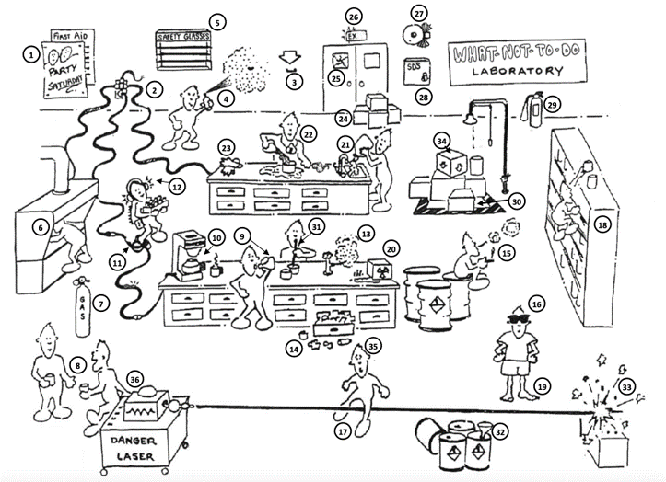
Image: The Laboratory Safety Institute (LSI)

