Introduction: Worksheet 1

Hazard symbols
Hazard symbols (also known as pictograms) are used to communicate the hazards associated with substances. They are diamond in shape with a white background and red border. The presence of hazard symbols on bottles or containers can be used to establish appropriate control measures for these hazardous substances. Knowing which symbol represents which hazard is therefore important. Hazard symbols are used to alert users to the possible harm that these substances might cause to people or the environment.

Matching hazard symbols
Write the name of each hazard next to its symbol.

Hazard | Symbol
 | 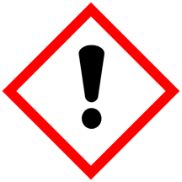
 | 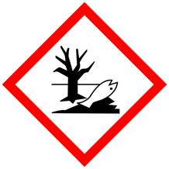
 | 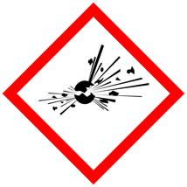
 | 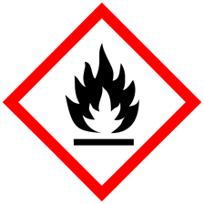
Hazard symbols are available at https://www.hse.gov.uk/chemical-classification/labelling-packaging/hazard-symbols-hazard-pictograms.htm
Contains public sector information published by the Health and Safety Executive and licensed under the https://www.nationalarchives.gov.uk/doc/open-government-licence/version/3/

Hazard | Symbol
 | 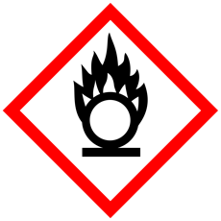
 | 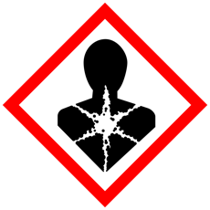
 | 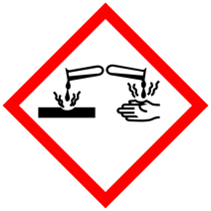
 | 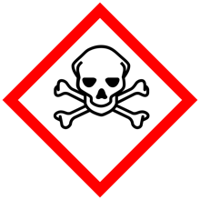
 | 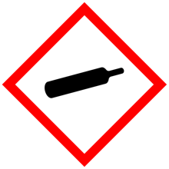

Hazard symbols are available at https://www.hse.gov.uk/chemical-classification/labelling-packaging/hazard-symbols-hazard-pictograms.htm
Contains public sector information published by the Health and Safety Executive and licensed under the https://www.nationalarchives.gov.uk/doc/open-government-licence/version/3/

